**VPC**

**Virtual private cloud**

**Create a VPC**

**Select vpc from the services in the services block**

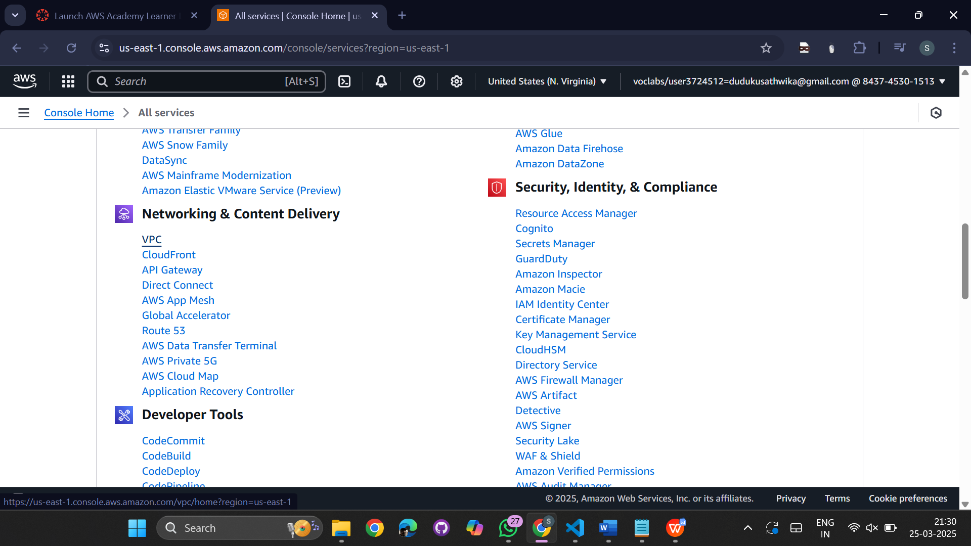  
  
  
click on create vpc

  
  
**Create VPC by giving a name and IPv4/CDR 10.0.0.0/16**

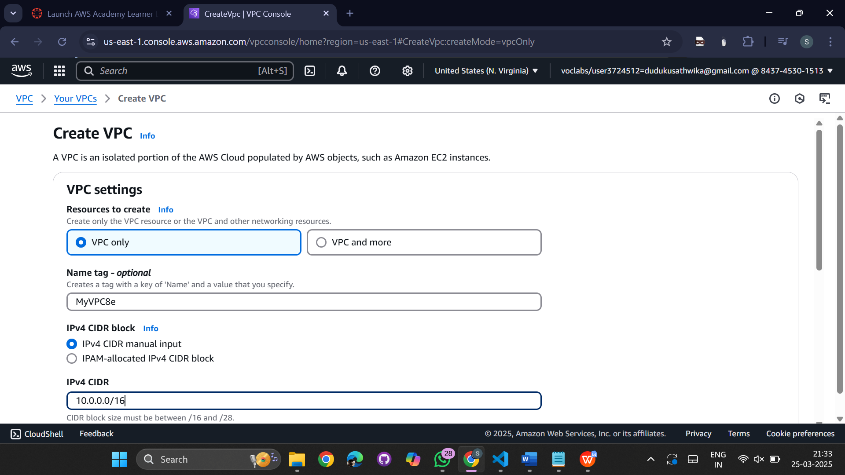  
  
**Create two subnets**

**subnet1 - 10.0.1.0/24 - Web-Server  
Select the vpc id before creating any subnet**

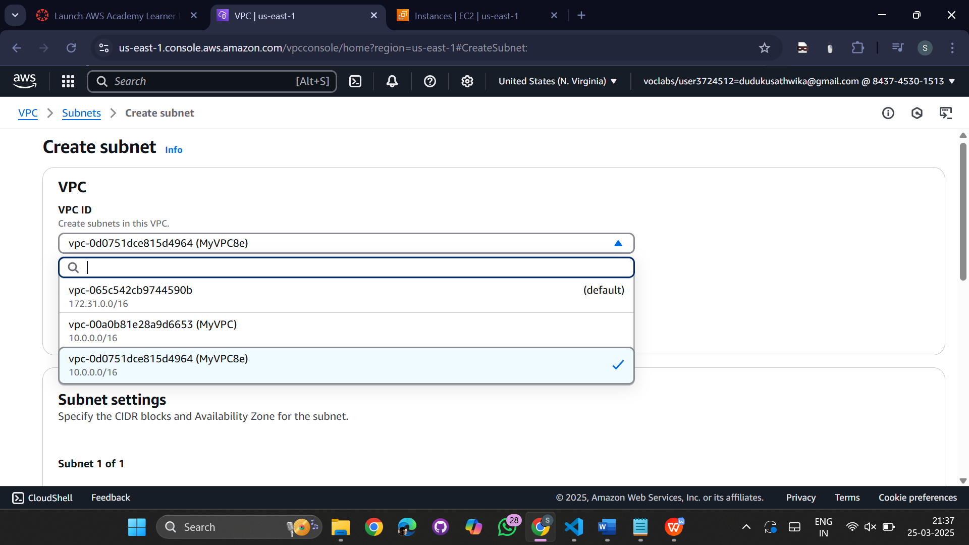

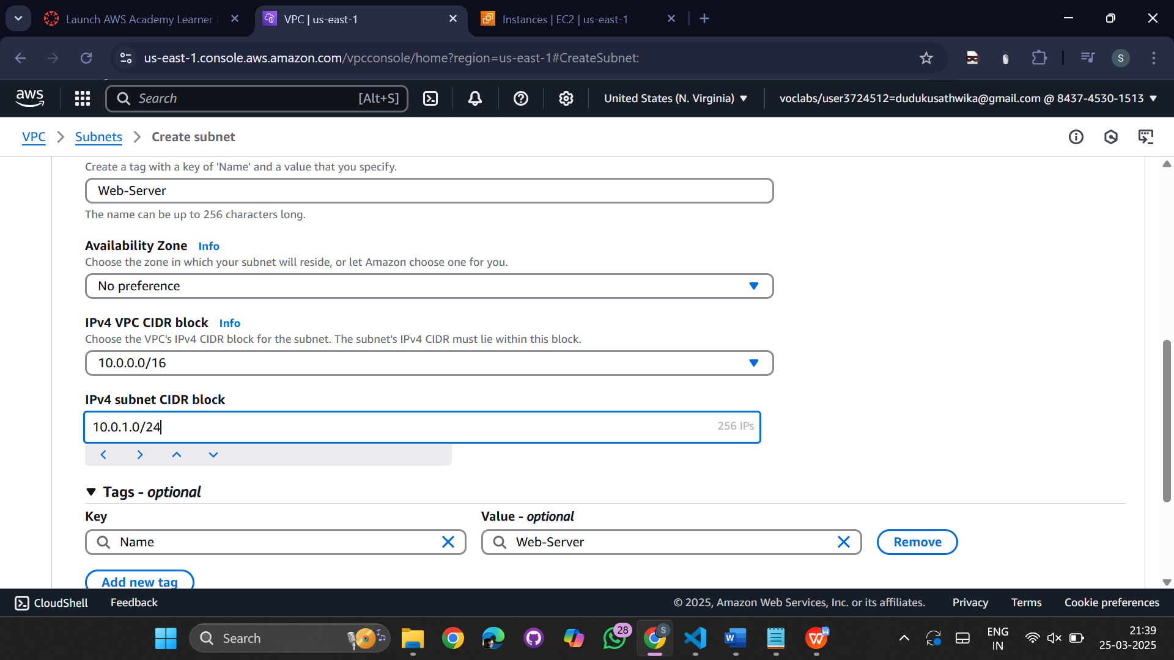  
  
subnet2 - 10.0.2.0/24 - Db-Server  
  
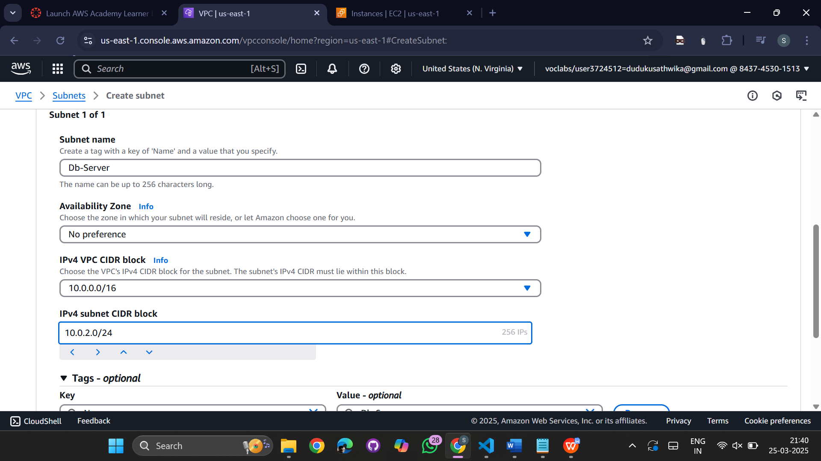  
  
Enable public IP to subnet1  
  
select subnet 1->edit subnet settings  
  
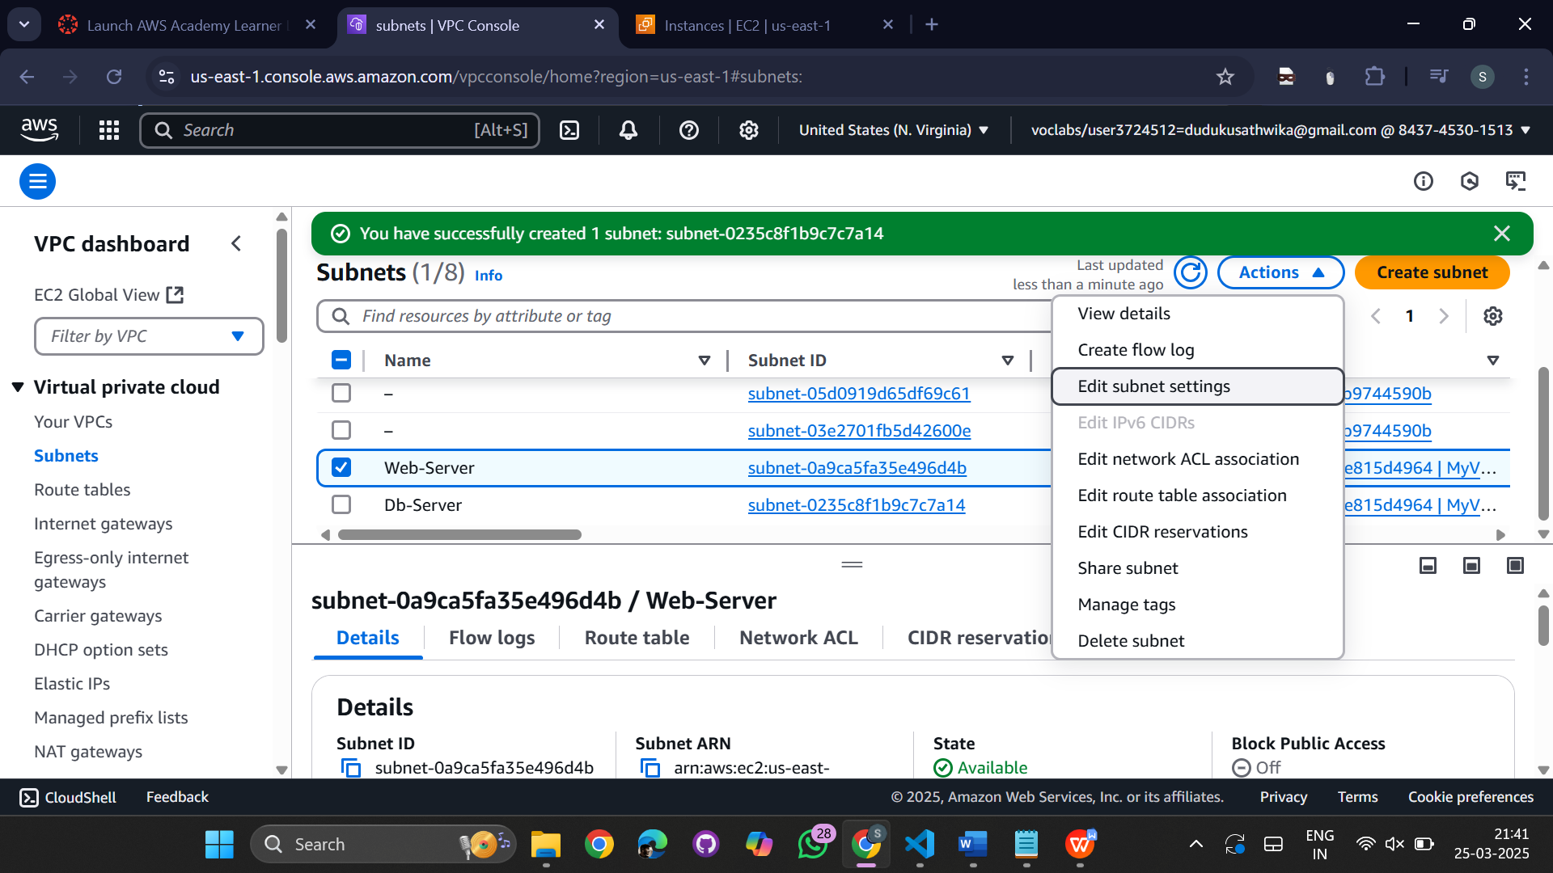

**Check the box enable auto-assign public IPV4 address to make subnet public**

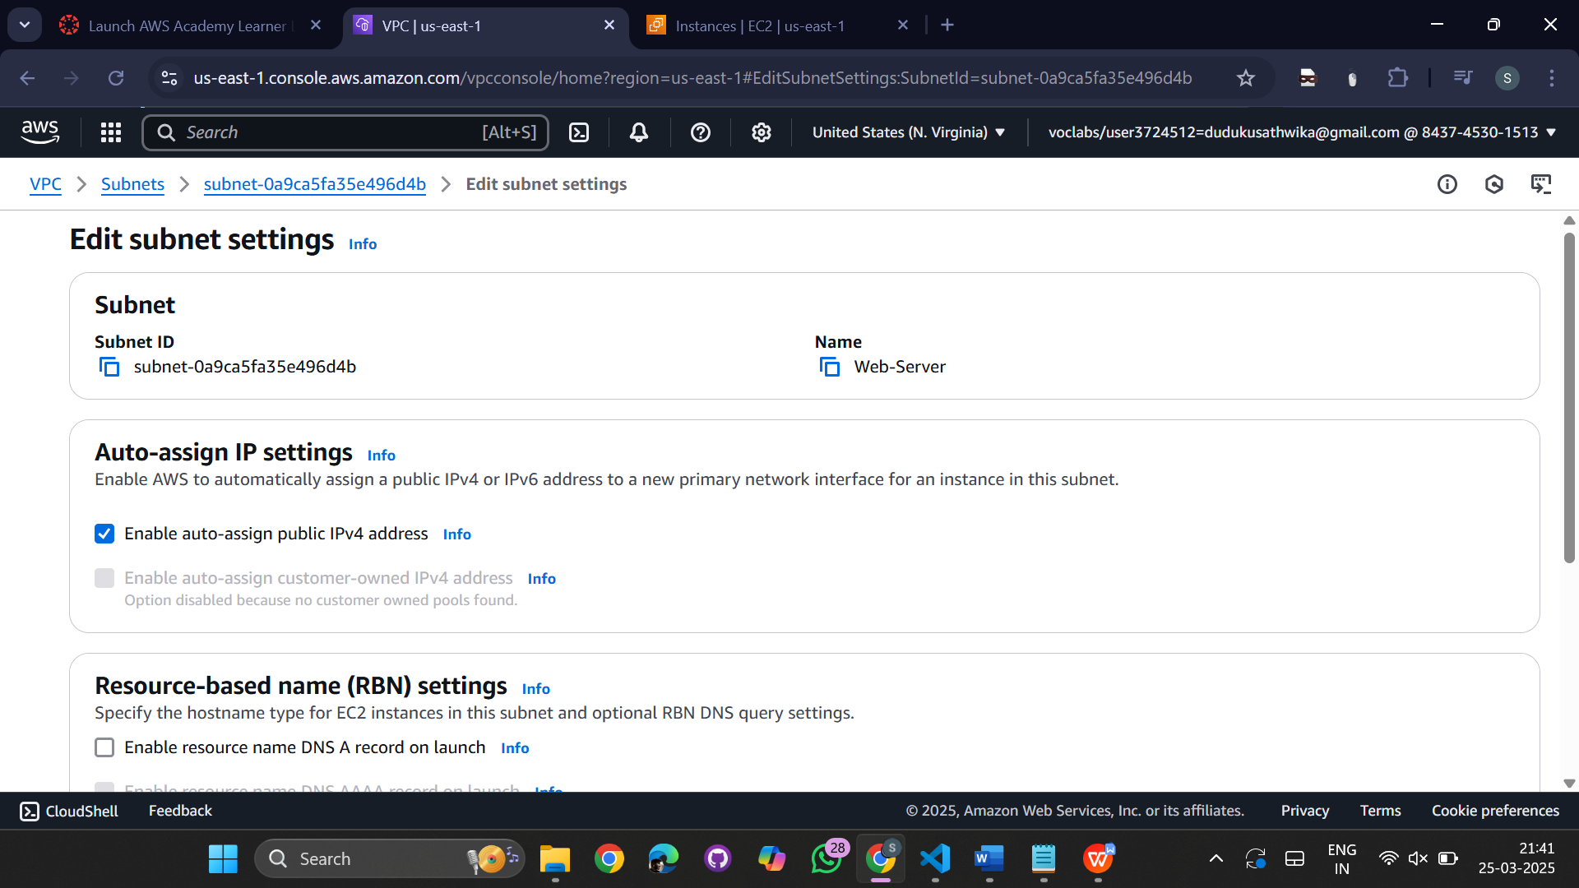

Create Internet Gateway attach to VPC -- MyIGW  
  
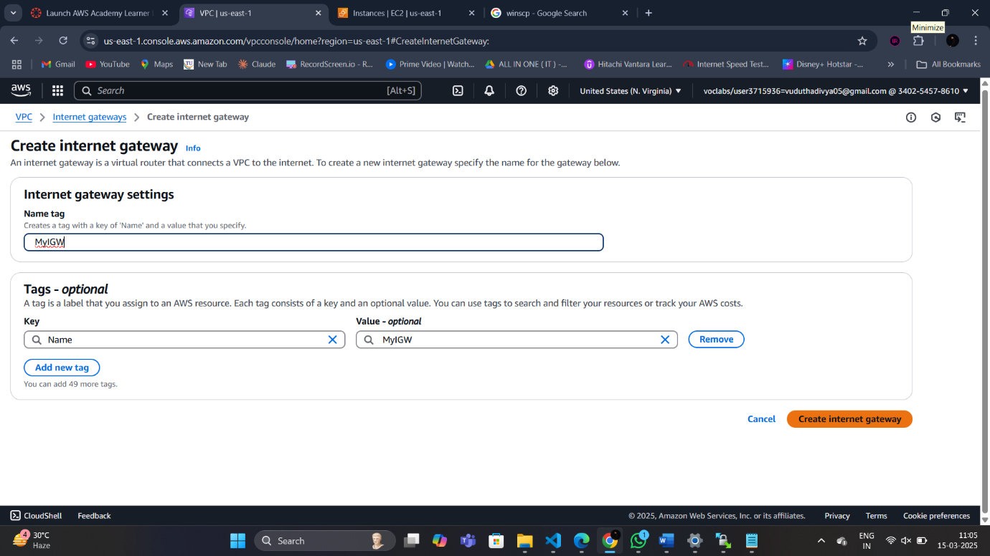  
  
Create Route table -- InternetRT  
  
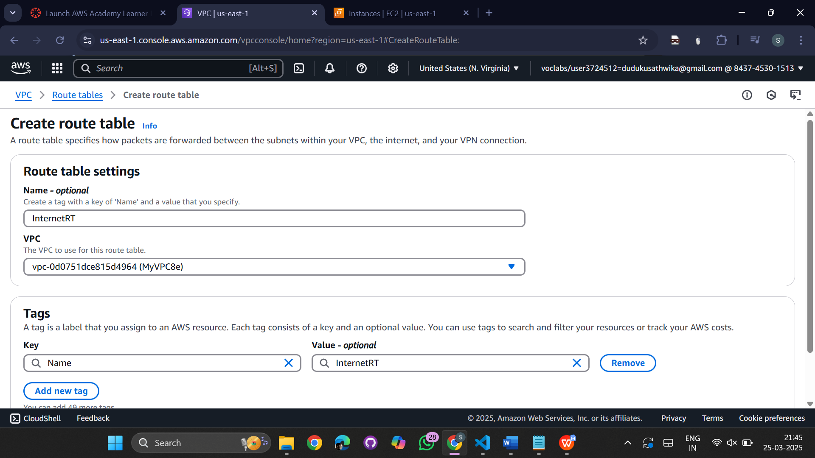  
  
Attach Route table to subnet1  
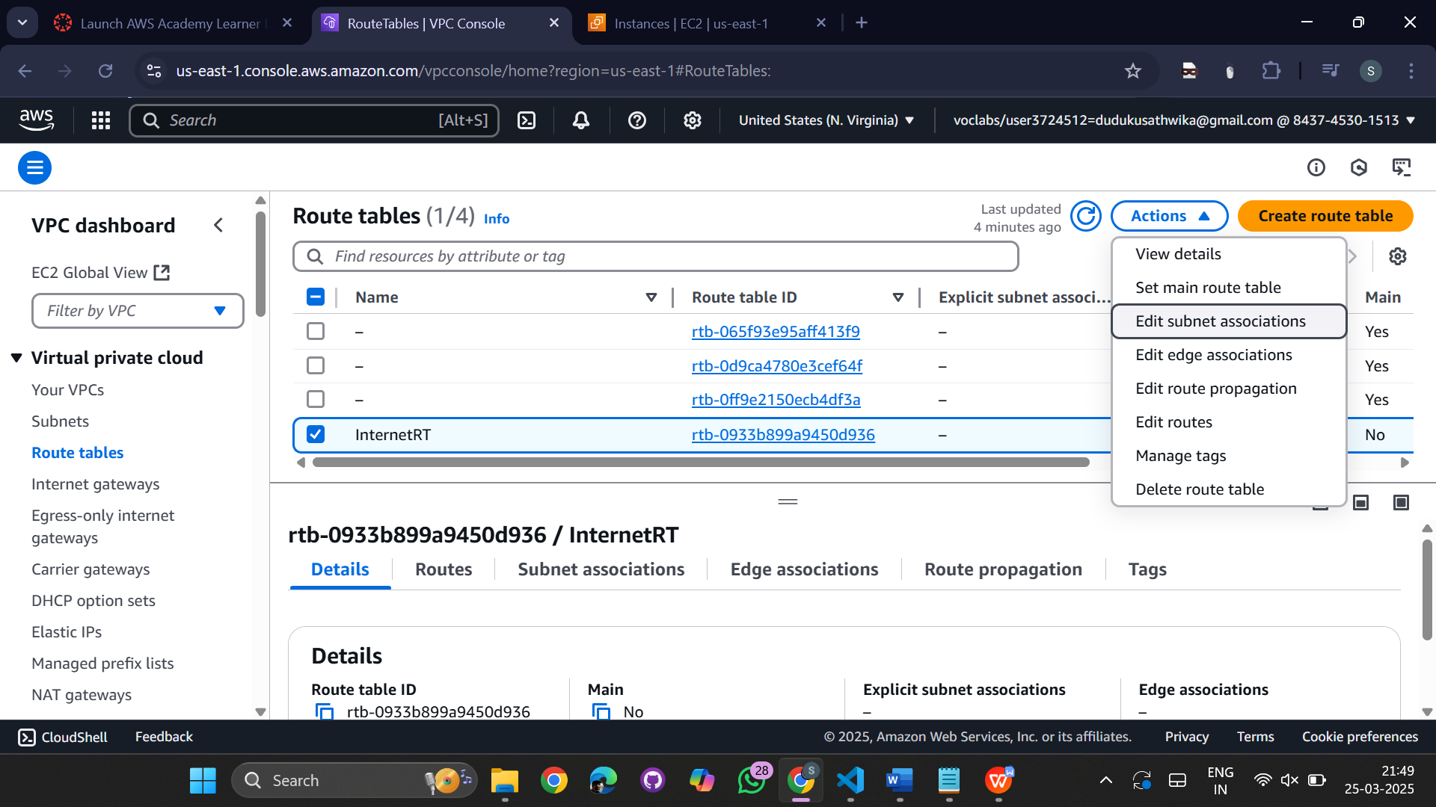  
  
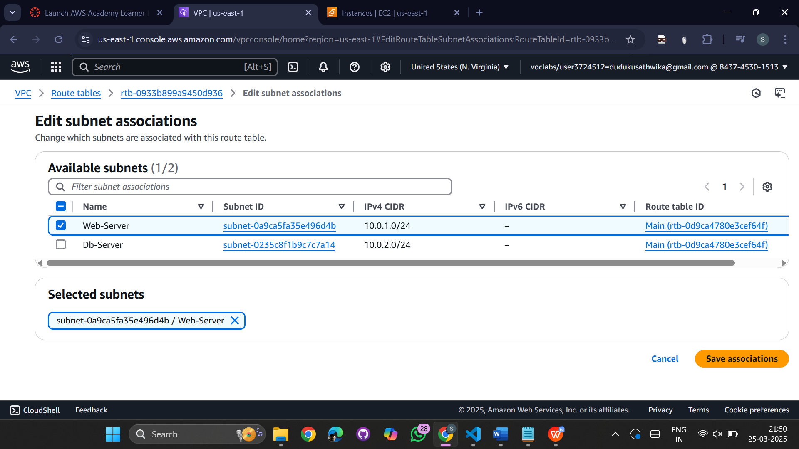  
  
Attach Route table to Internet Gateway  
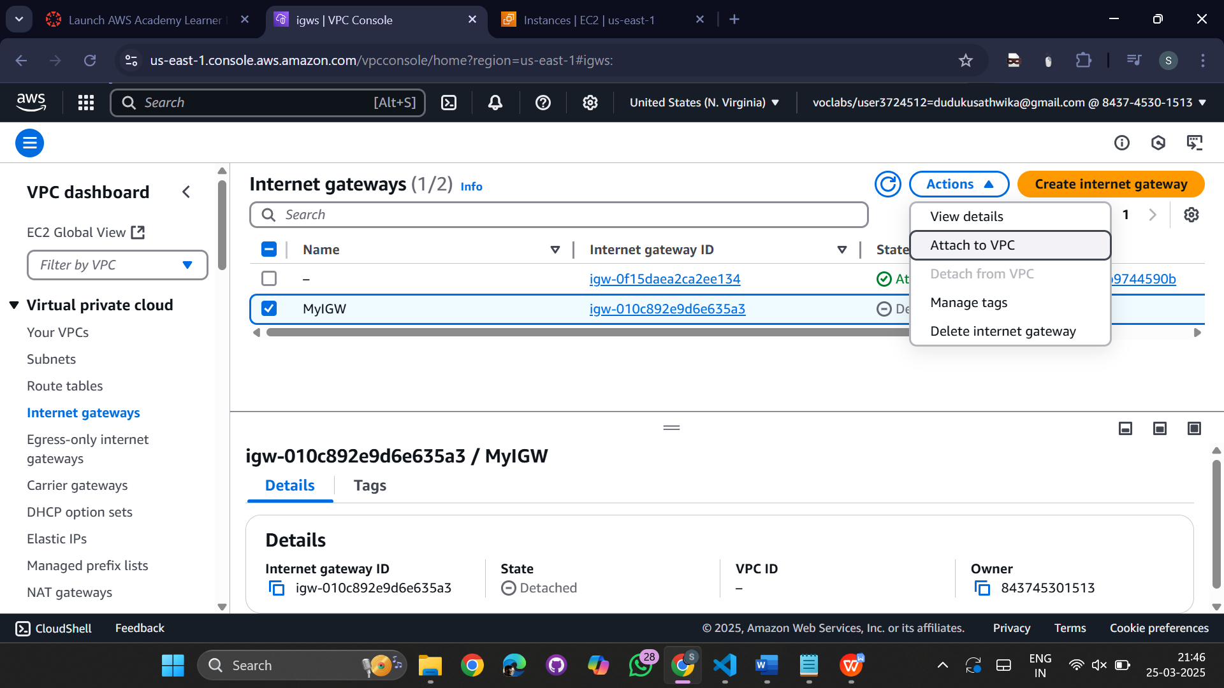  
  
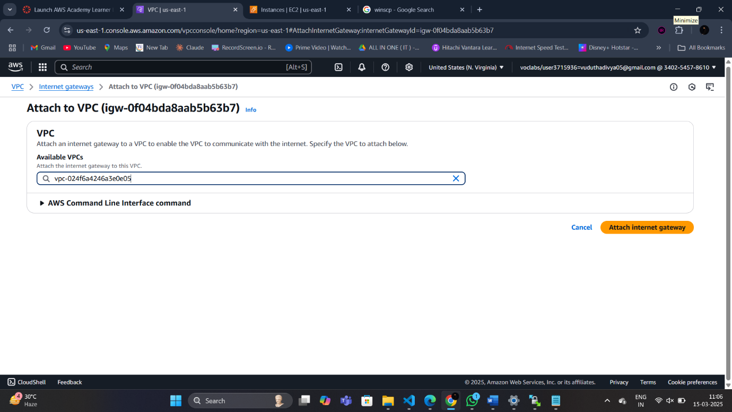  
  
**Attach Route table to Internet Gateway**

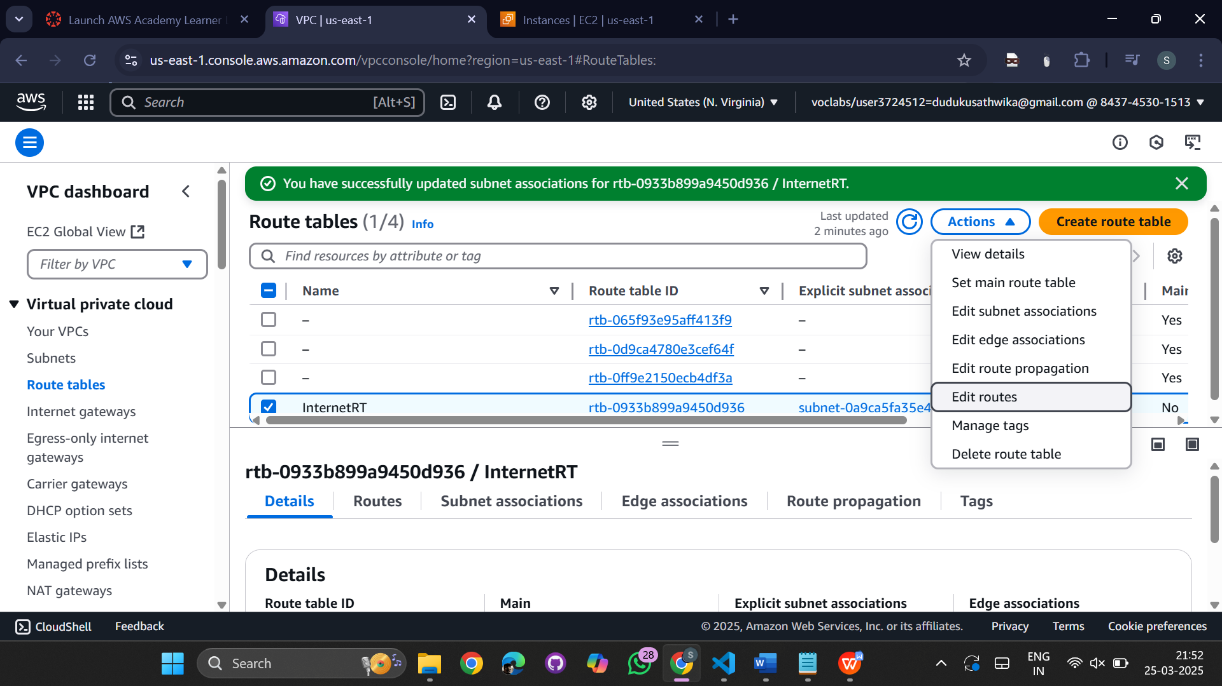  
  
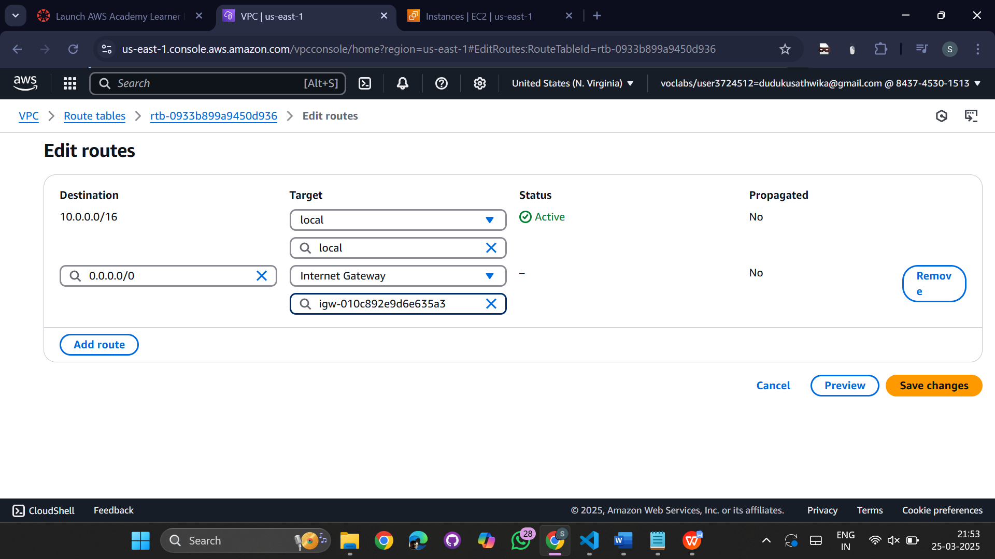  
  
  
Now, Lets launch web-server in public subnet.

Services ---Ec2 ---- Launch instance --

Name : WebServer

AMI : linux

keypair : webKP30.pem

Network : MyVPC

Subnet: 10.0.1.0/24

Security Group : Web-SG , Description: WebSG30

ADD RULE

Type Source

SSH Anywhere

HTTP Anywhere

Review and launch --- Launch -- Download Launch-- View Instance  
  
  
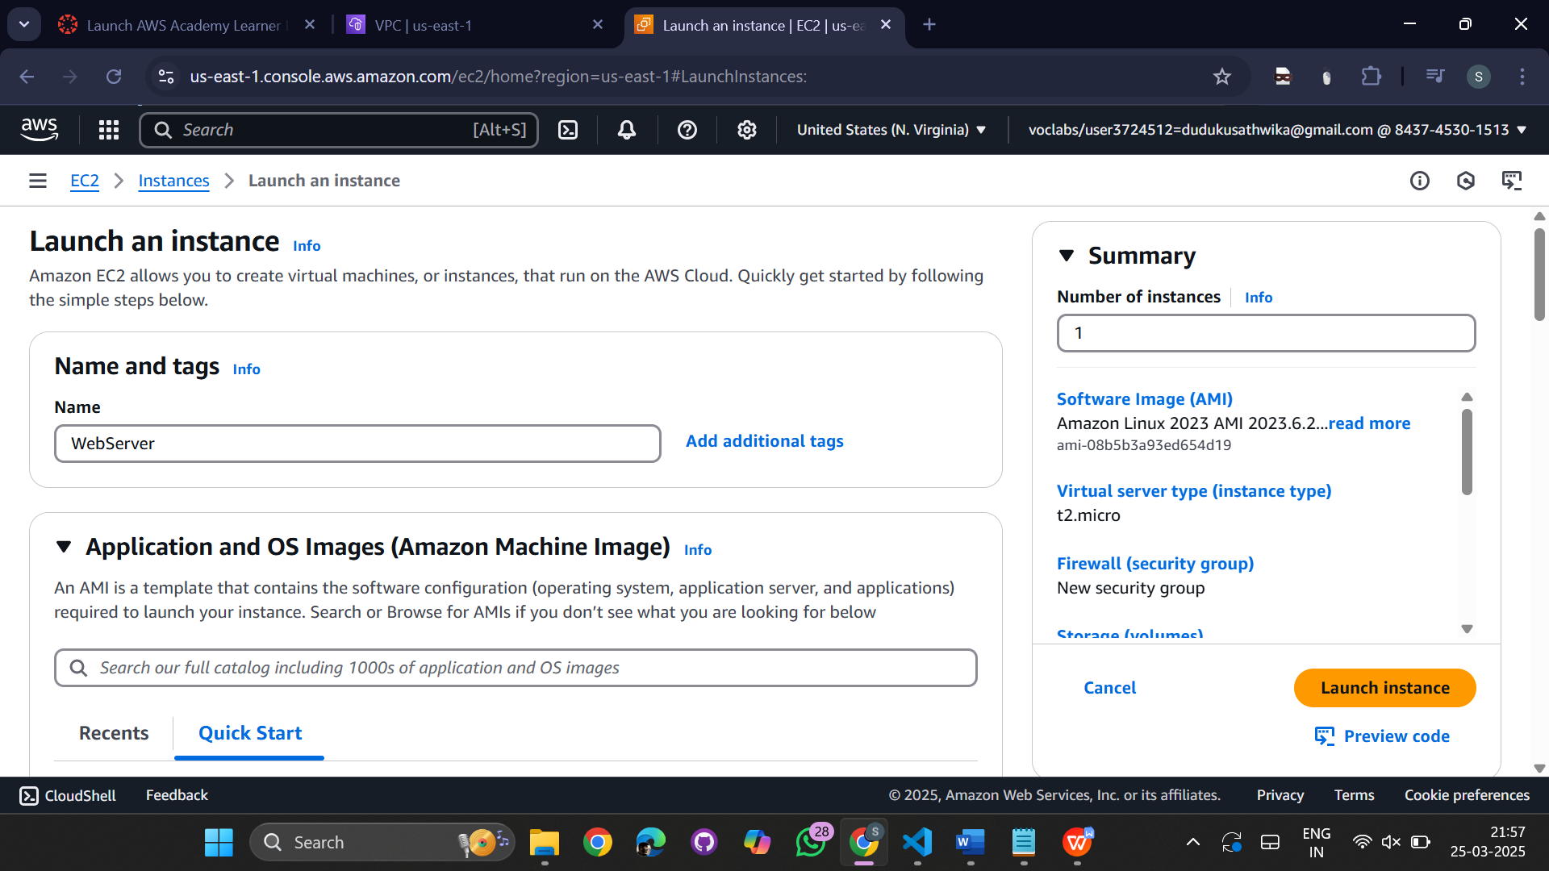  
  
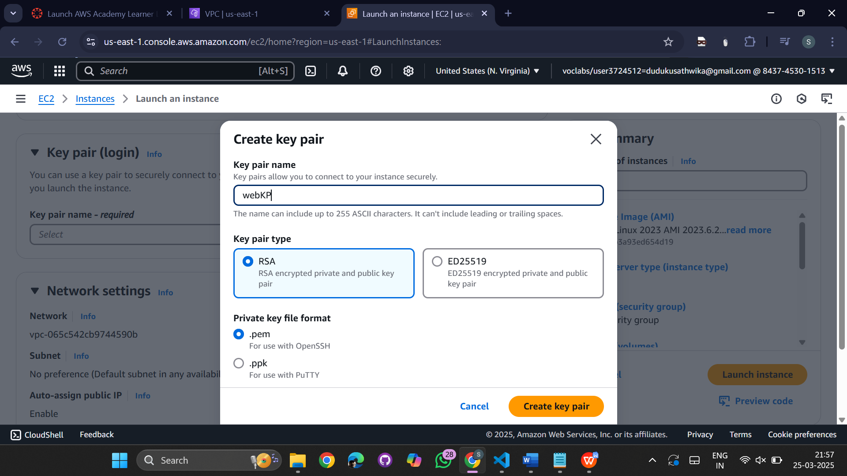  
  
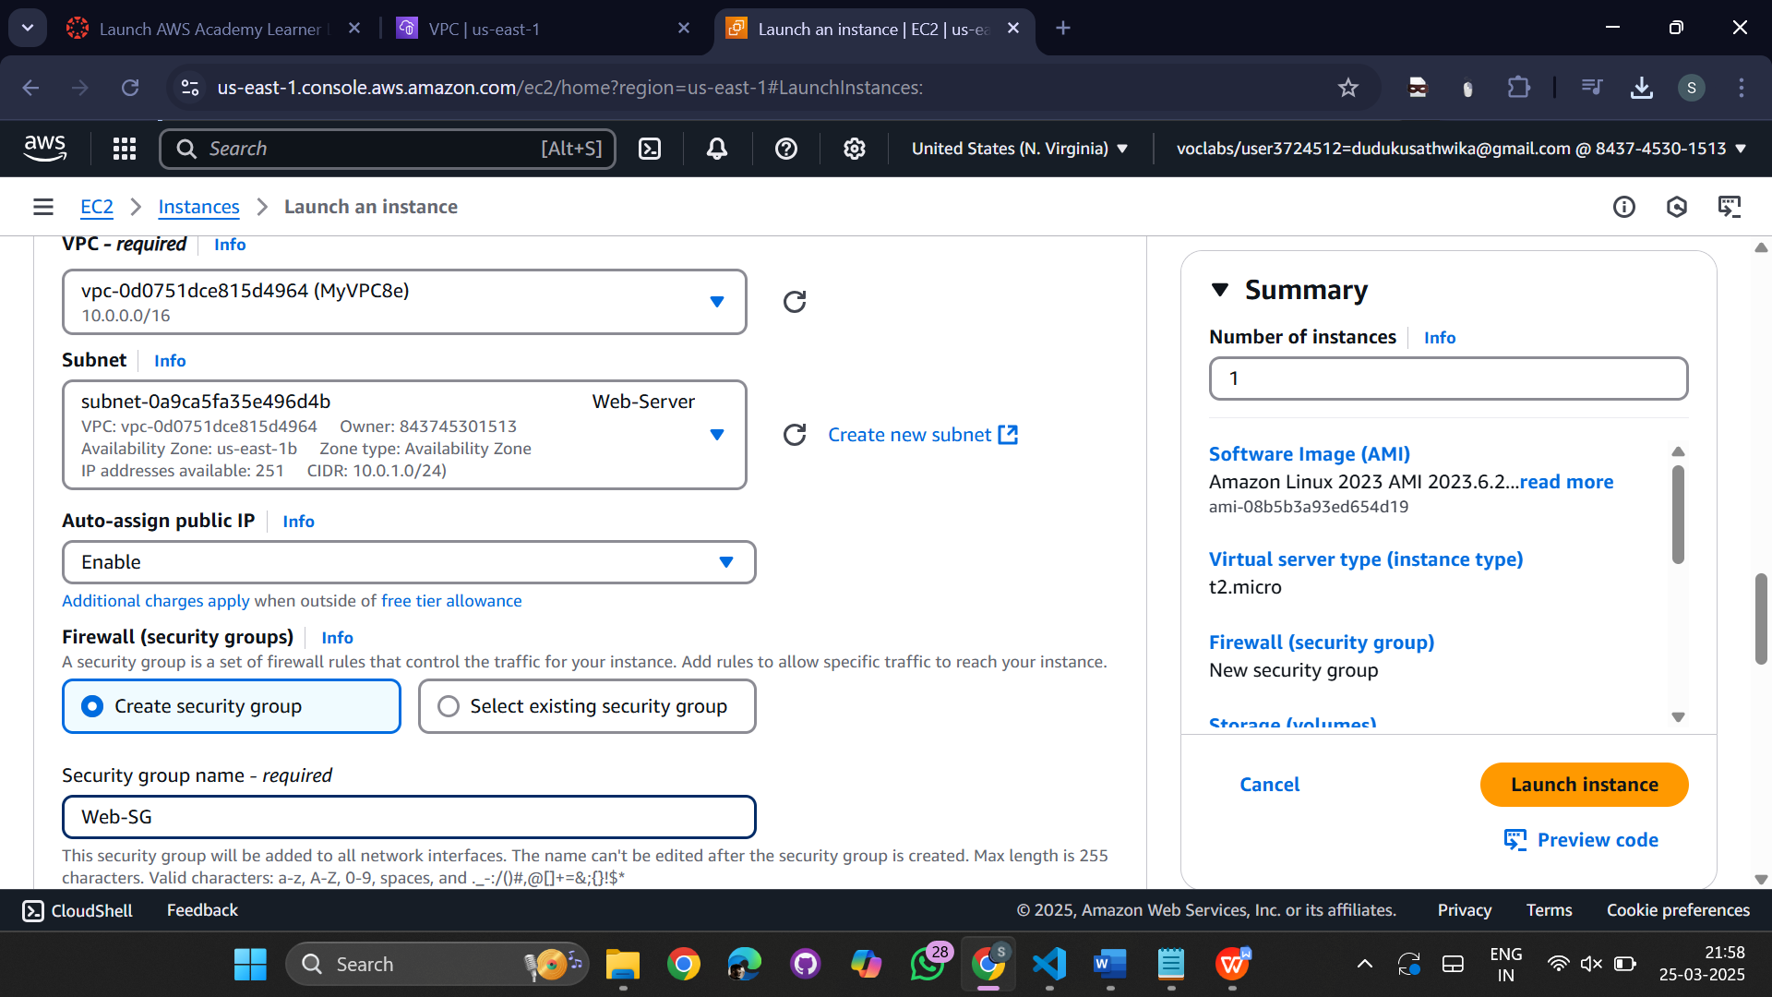  
  
Lets Launch Database Server in Private SUbnet.

Services ---Ec2 ---- Launch instance

Name : DbServer

AMI : Linux

Create new keypair --> (dbKP30.pem )

Network : MyVPC

Subnet: 10.0.2.0/24

Security Group : Db-SG , Description: DbSG30

Change Type from SSH to MYSQL/Aurora

Type Source

MYSQL/Aurora Custom 10.0.1.0/24

( MySQL Port is open to entire subnet )

Review and launch --> launch instances --- View instances

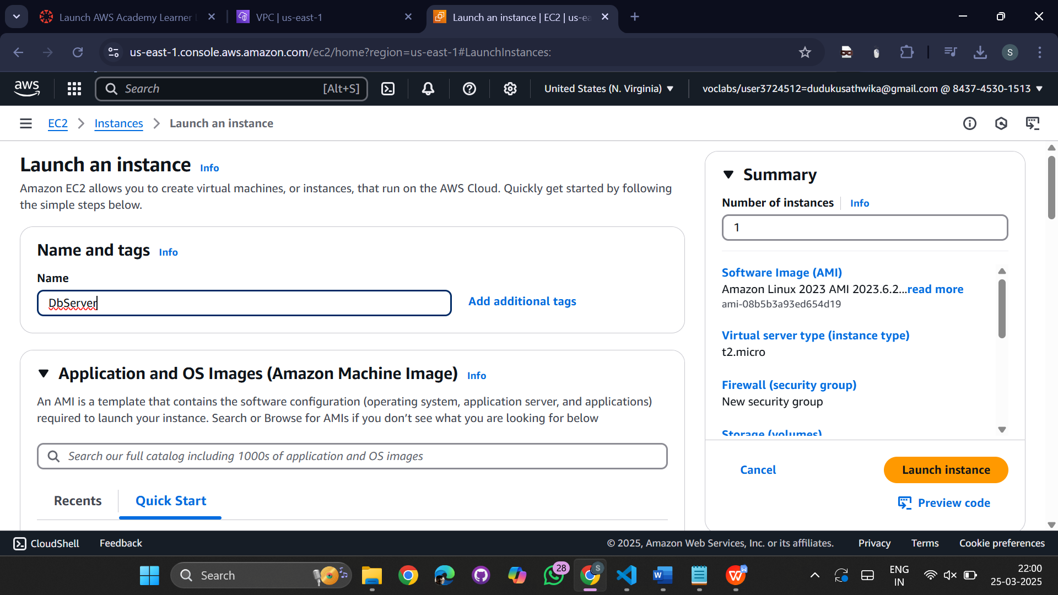  
  
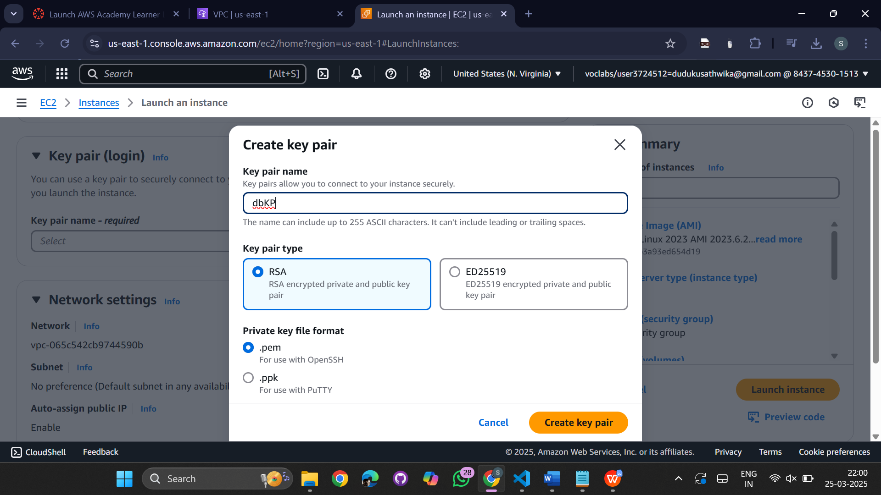  
  
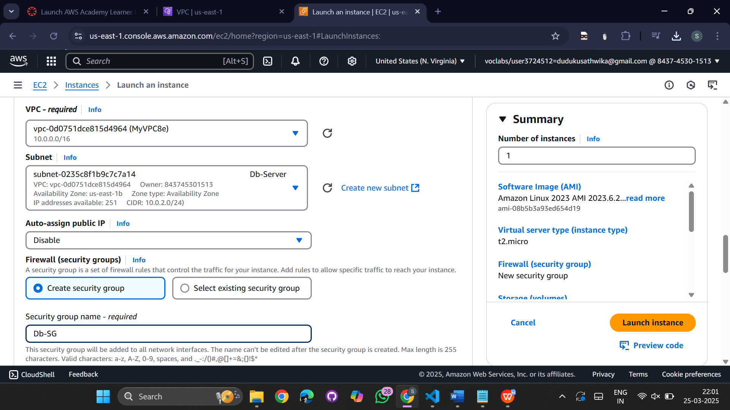  
  
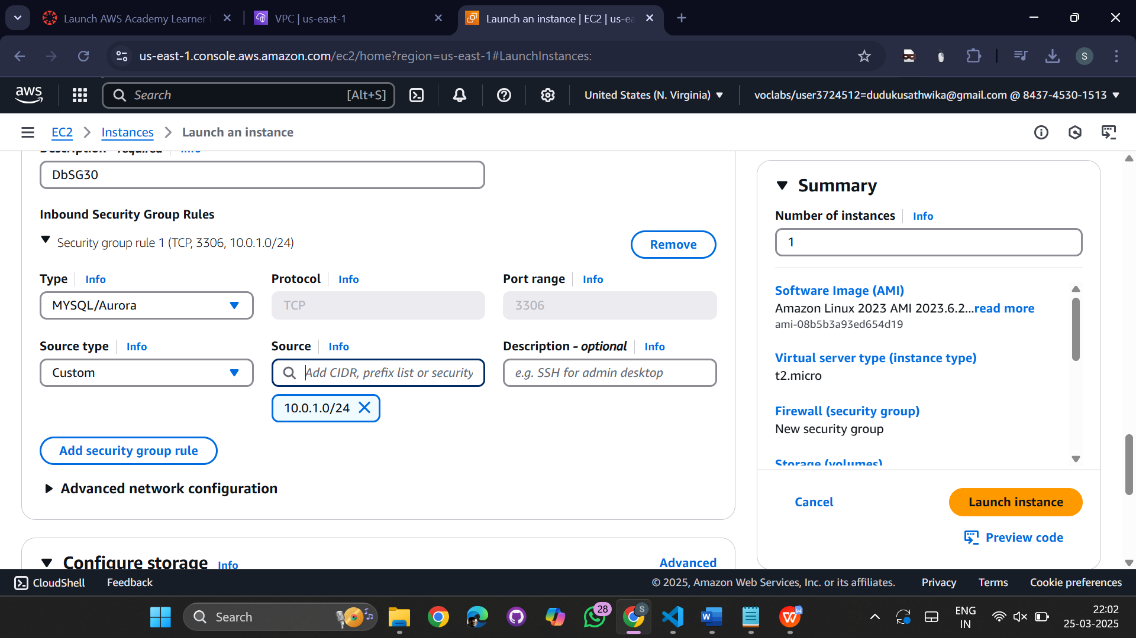  
  
  
Services -- EC2 -- Luanch -- Amazon Linux ---> select VPC , Select subnet

Name: BastionServer

Security Group: BastionSG30

Description: BastionSG30

(SSH port -- should be open to myself)

Type Source

SSH My IP  
  
  
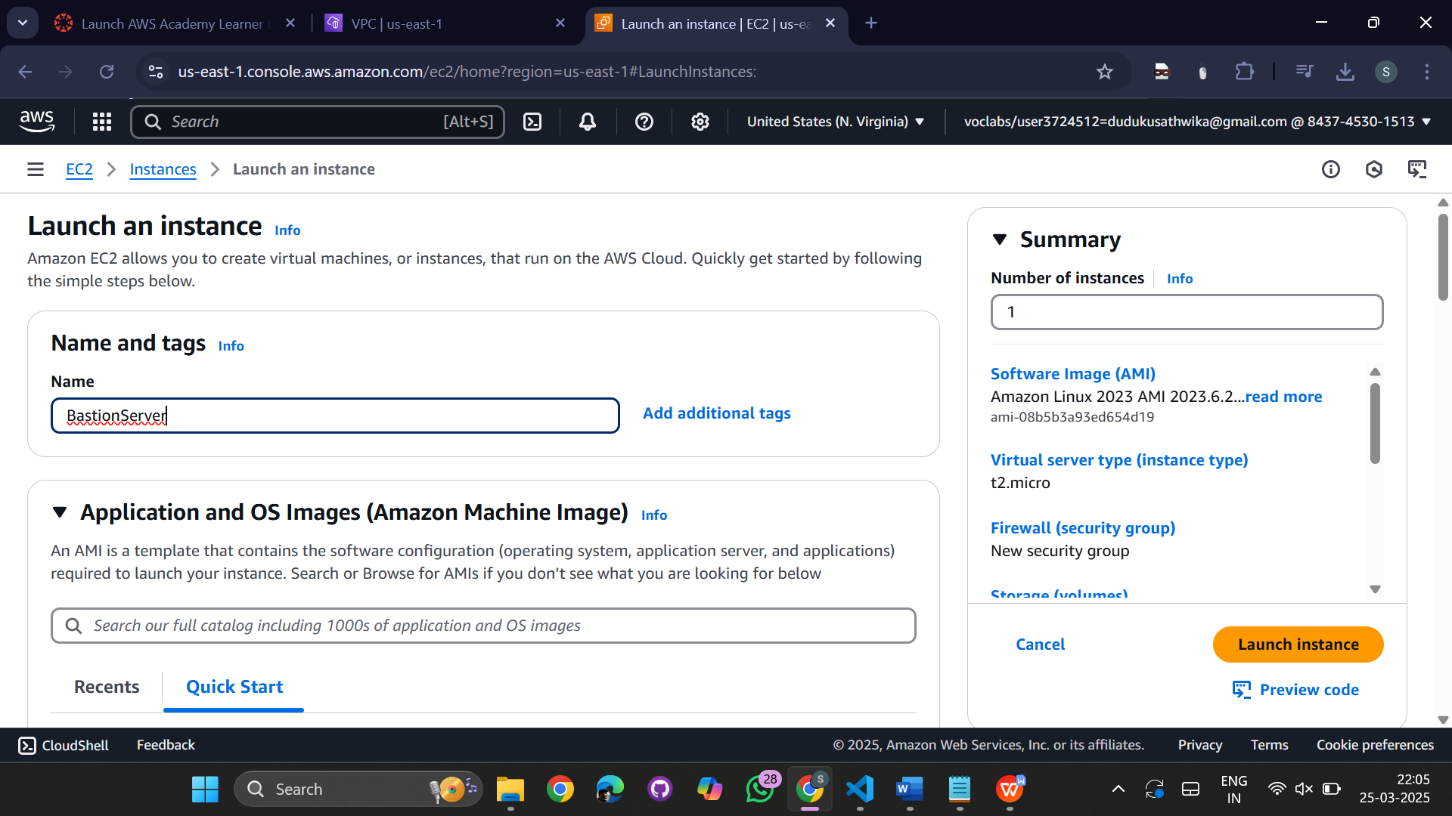  
  
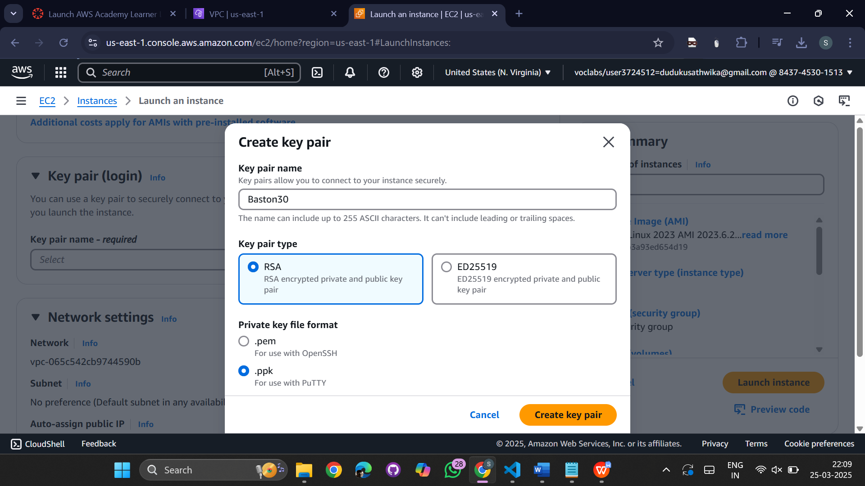  
  
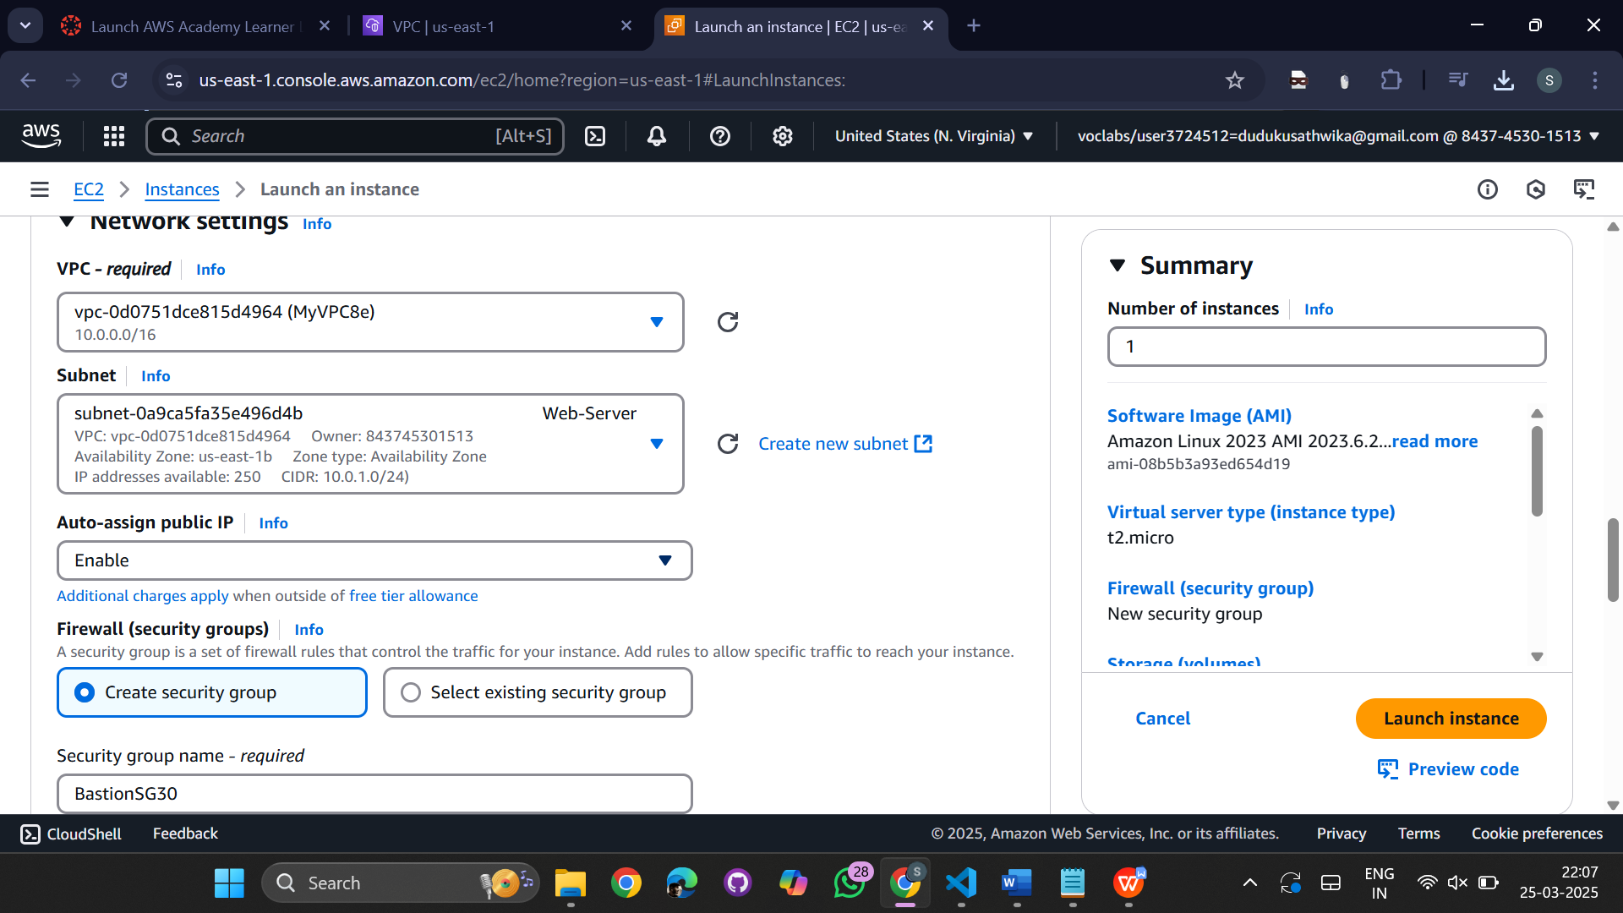  
  
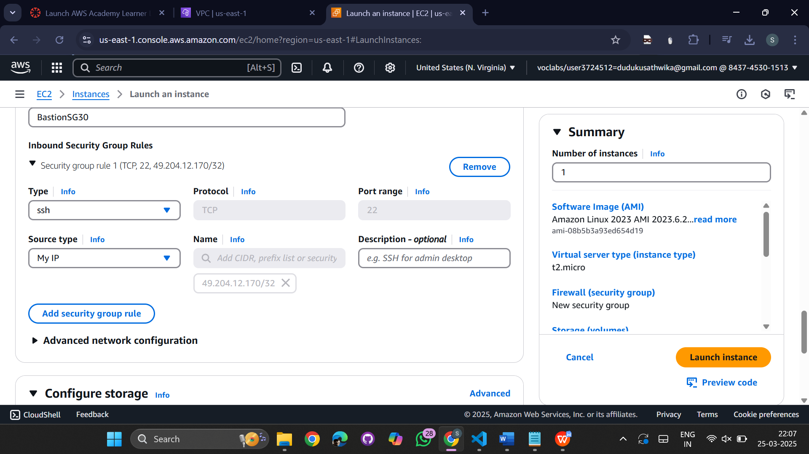

Goto Dbserver security group - DbSG30 ( new tab )

Select DbSG -- Inbound --Edit

Add Rule

Type Source

SSH Custom 10.0.1.231/32 ( Private IP of bastion server)

Save.

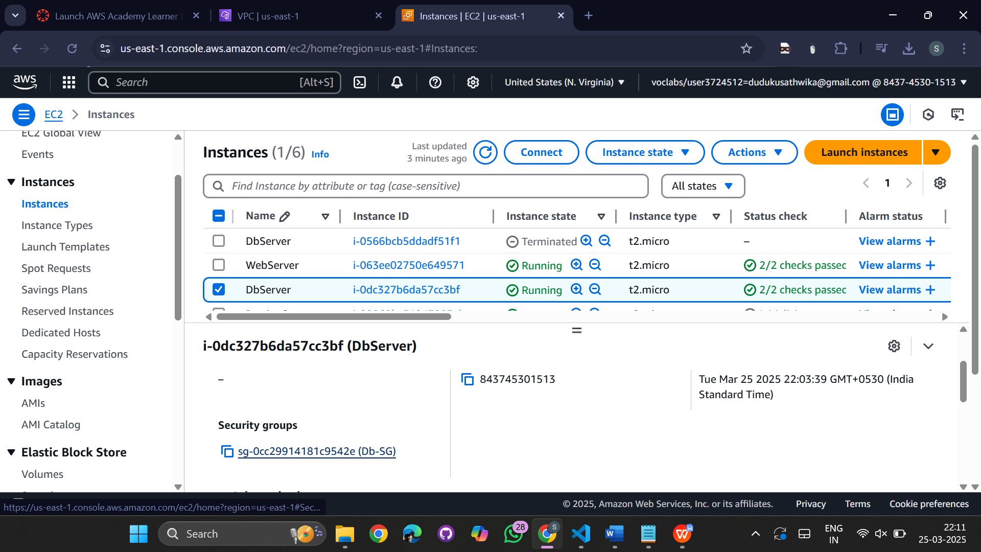  
  
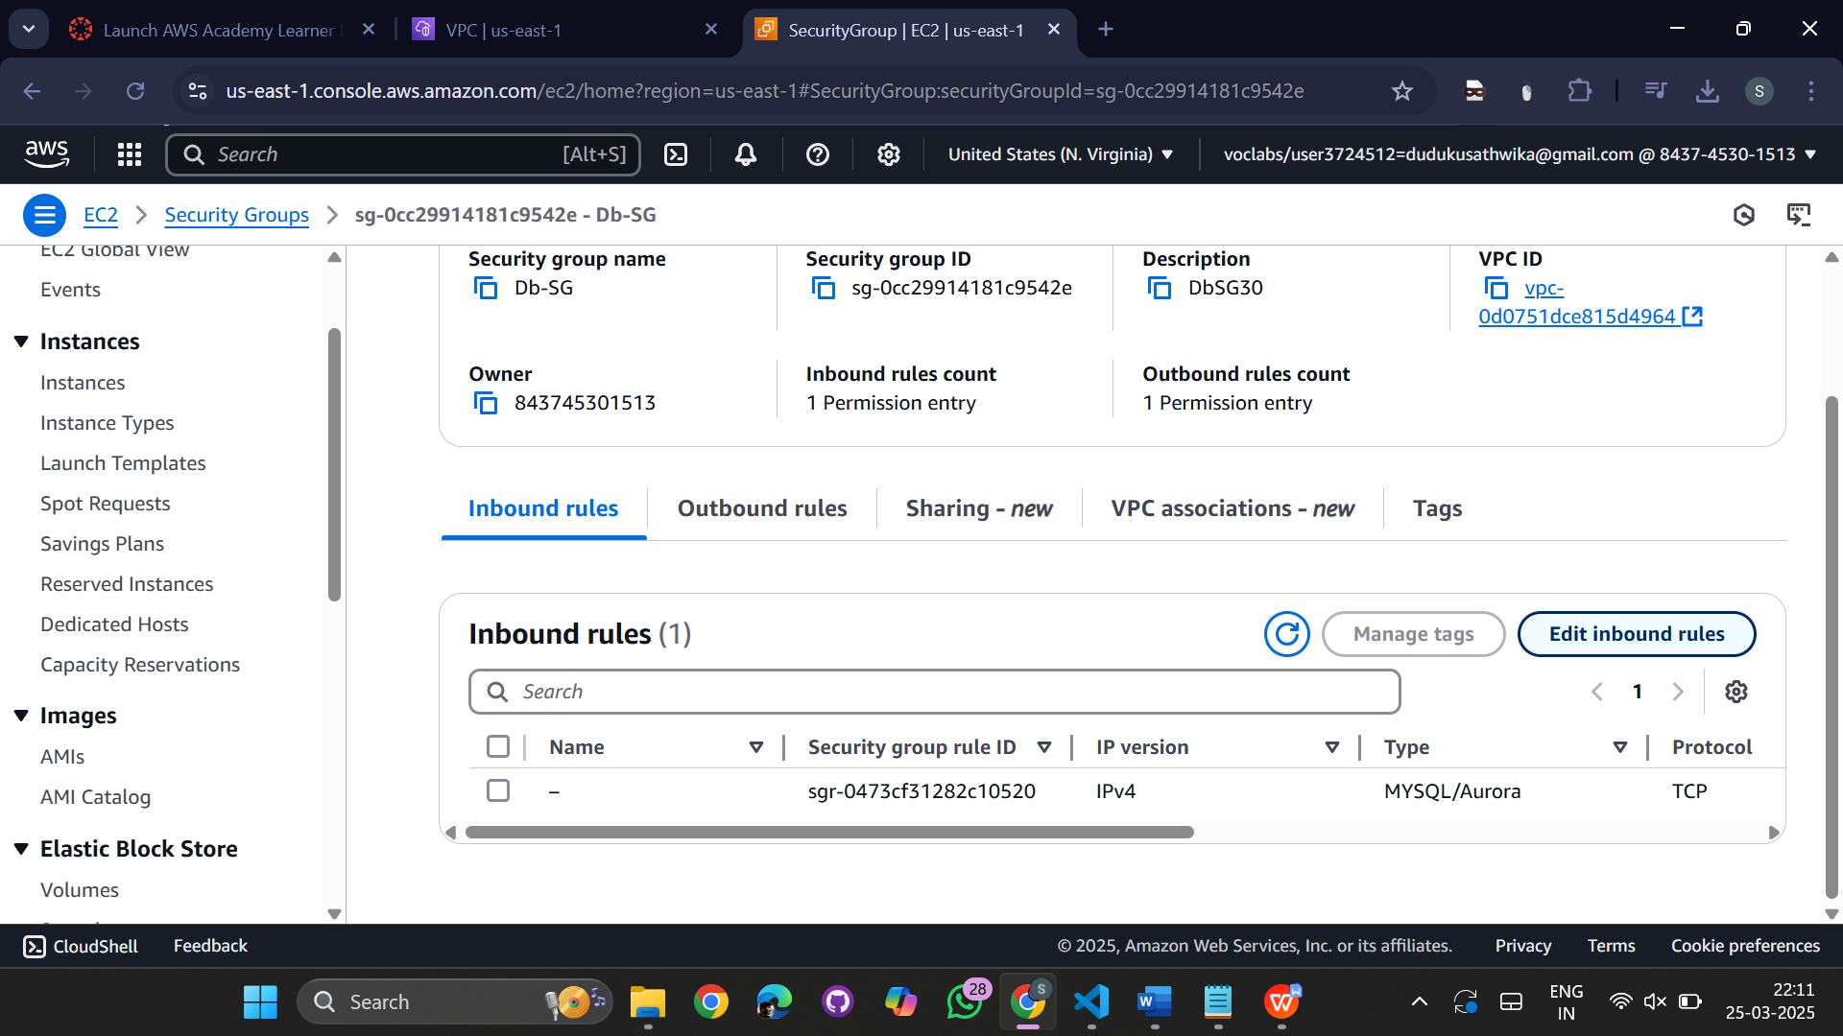  
  
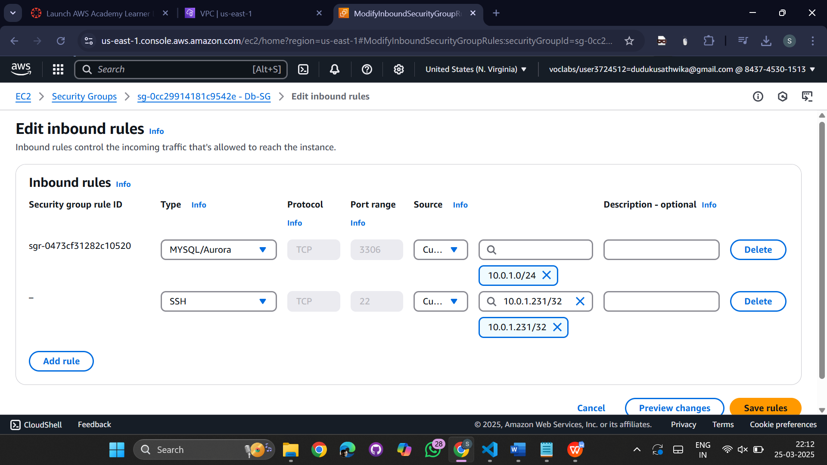  
  
**In EC2 Dashboard -- select bastion server -- connect**

**copy user@public_ip**

**Open putty**

**Host Name - user@public_ip**

**Provide PPK file -- Connect!**

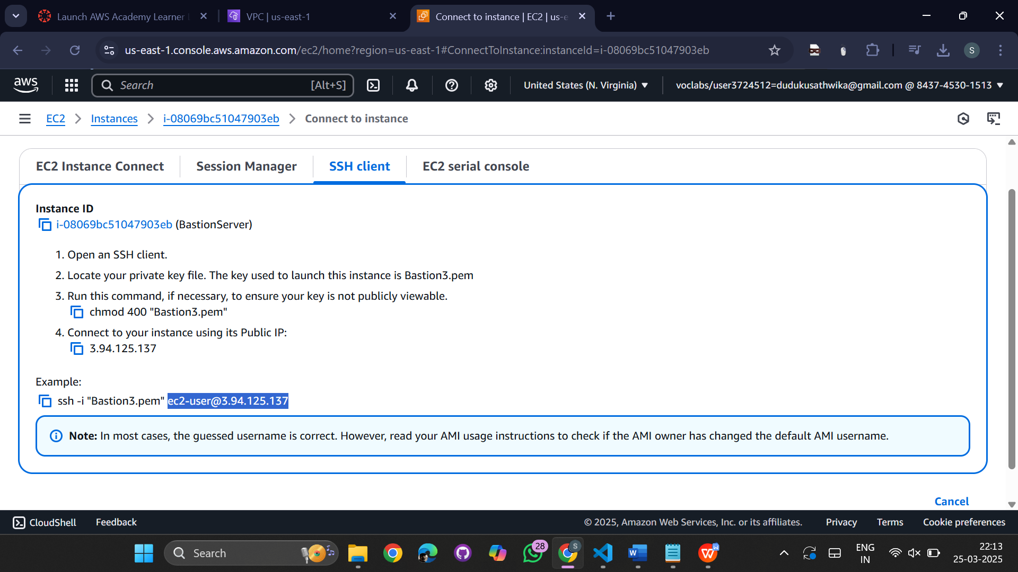  
  
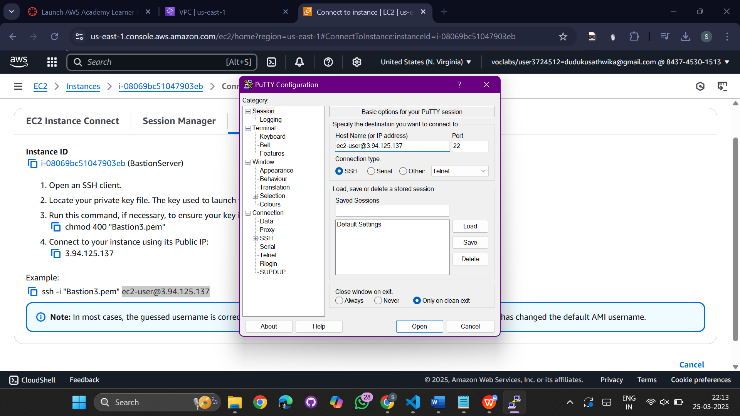  
  
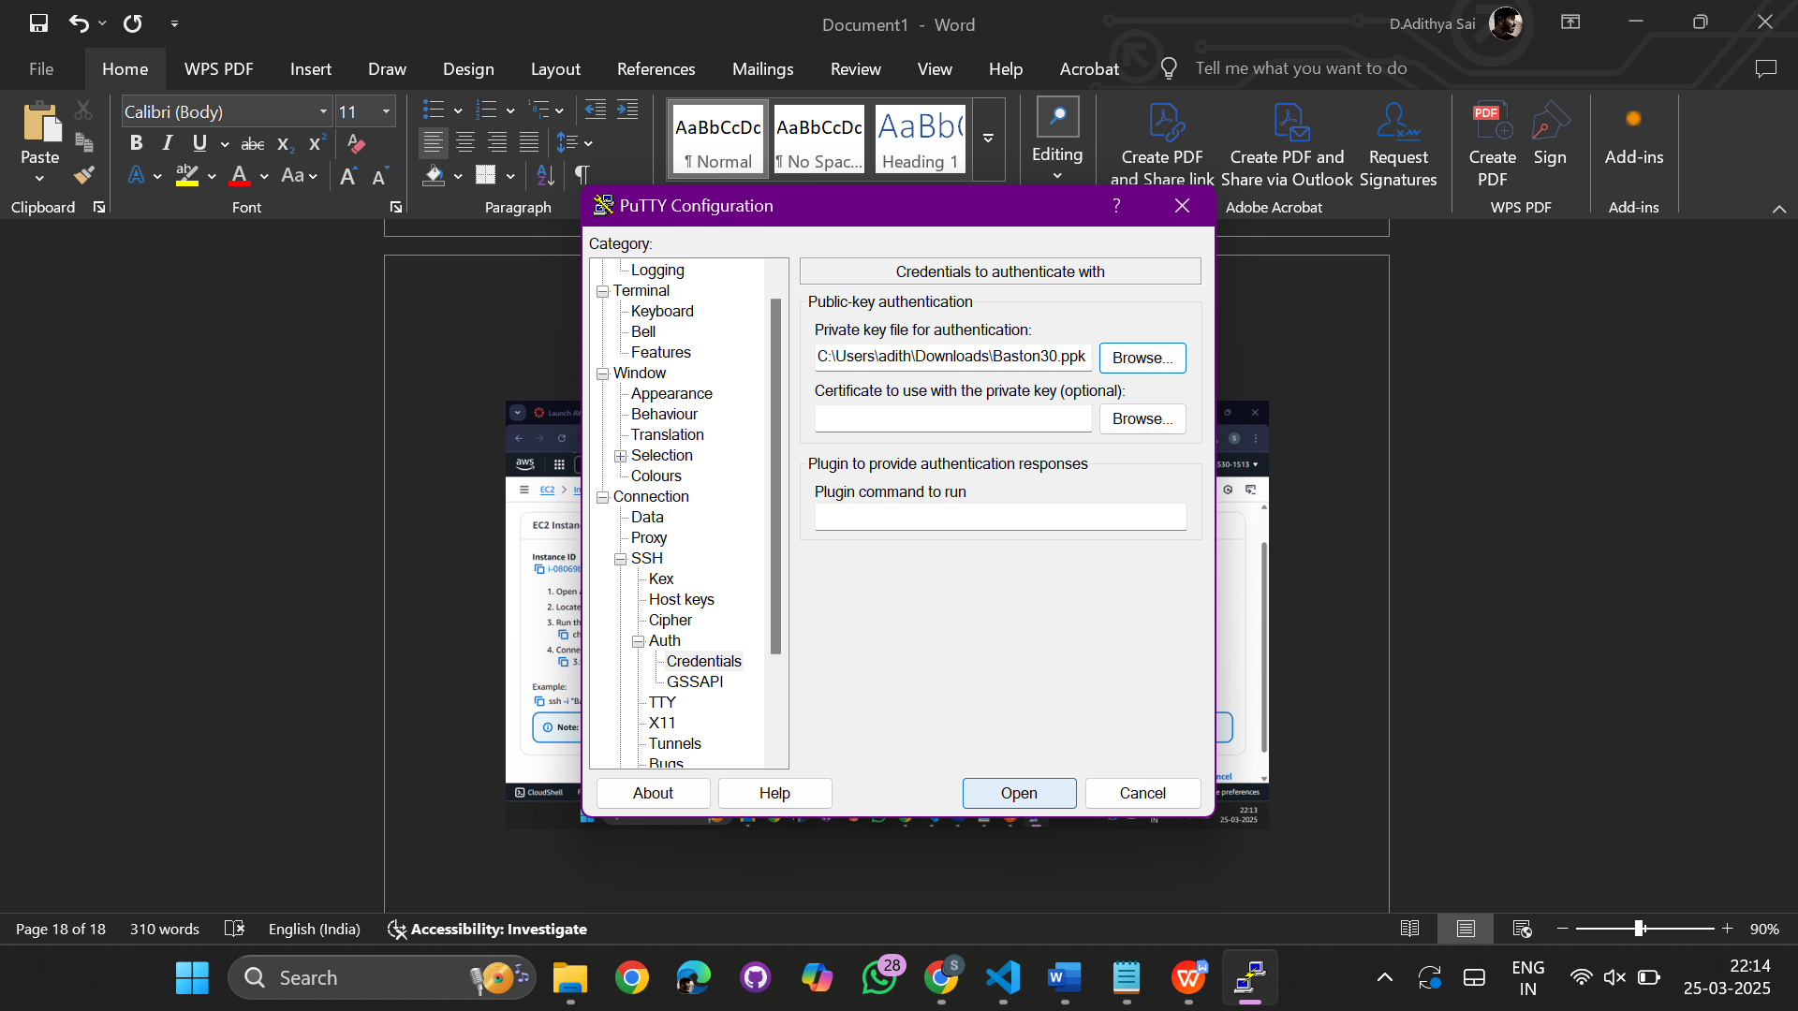  
  
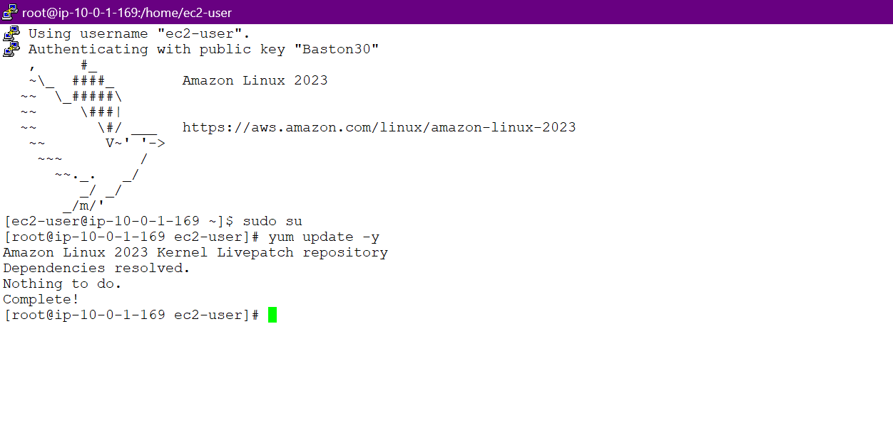  
  
  
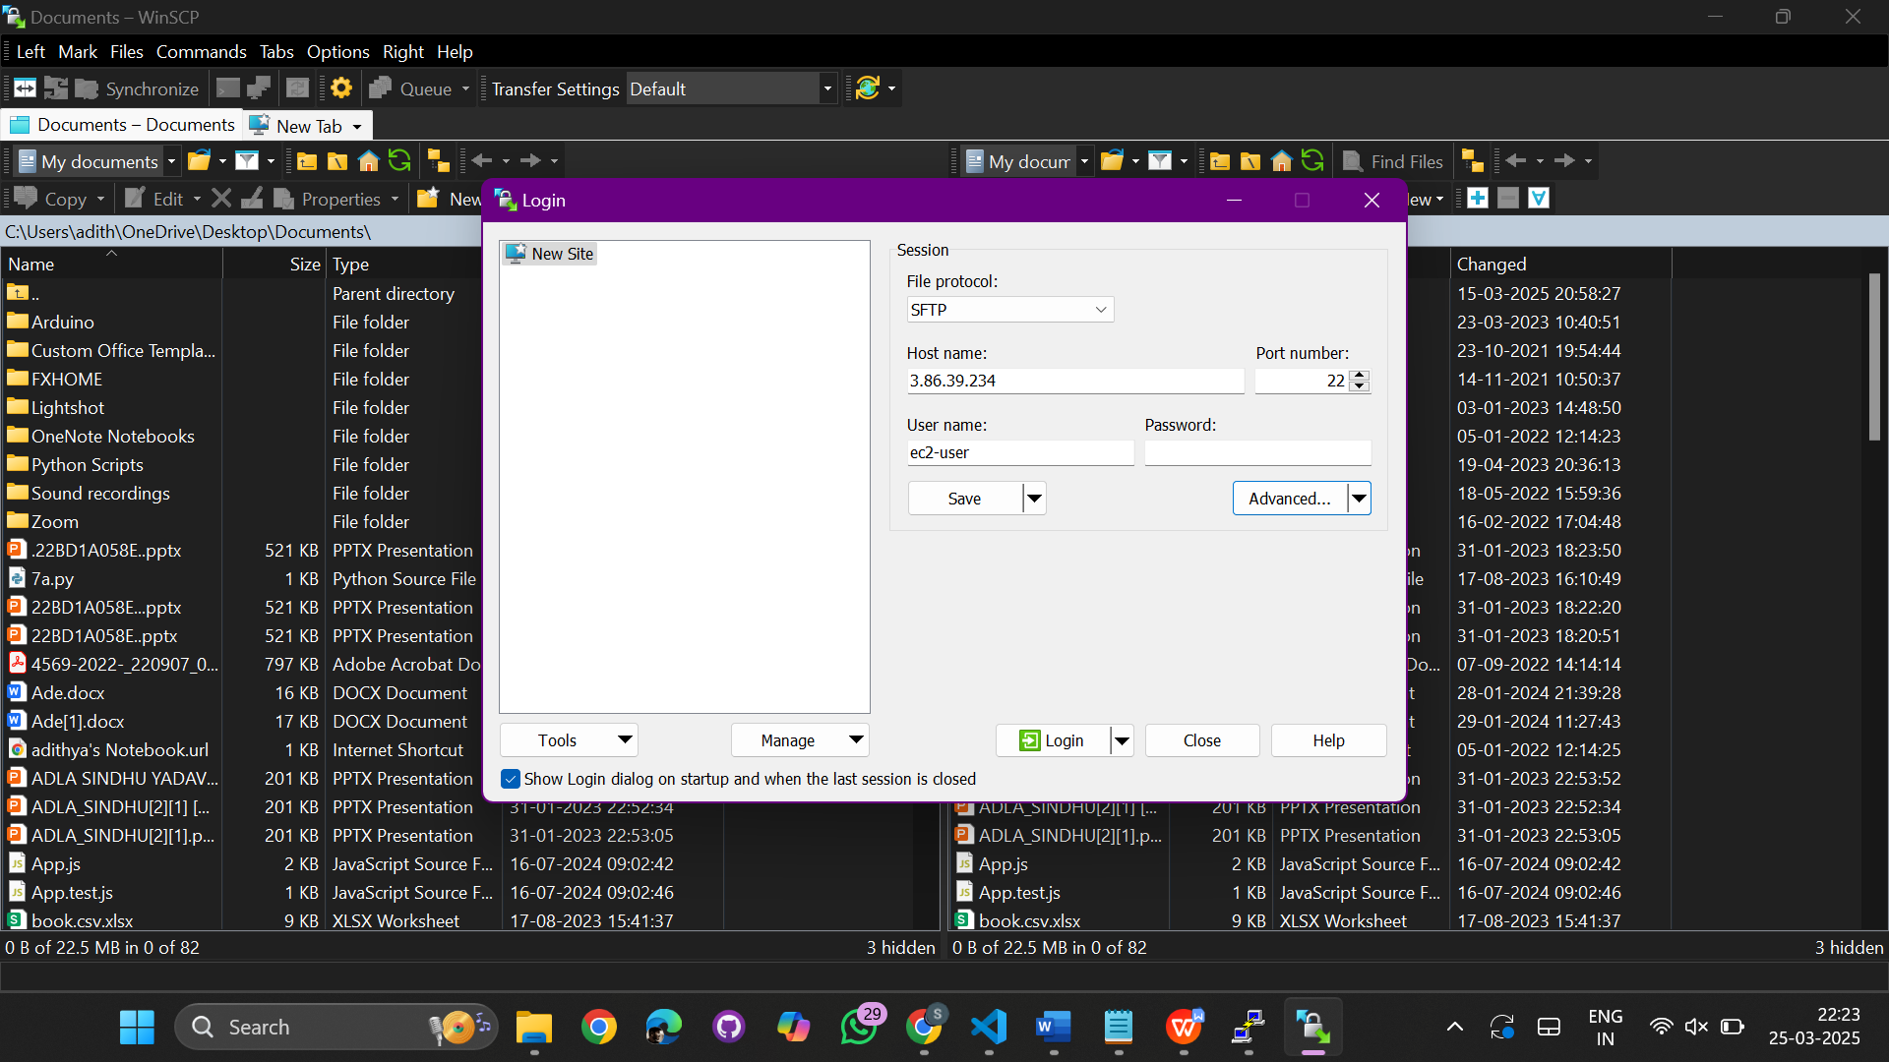  
  
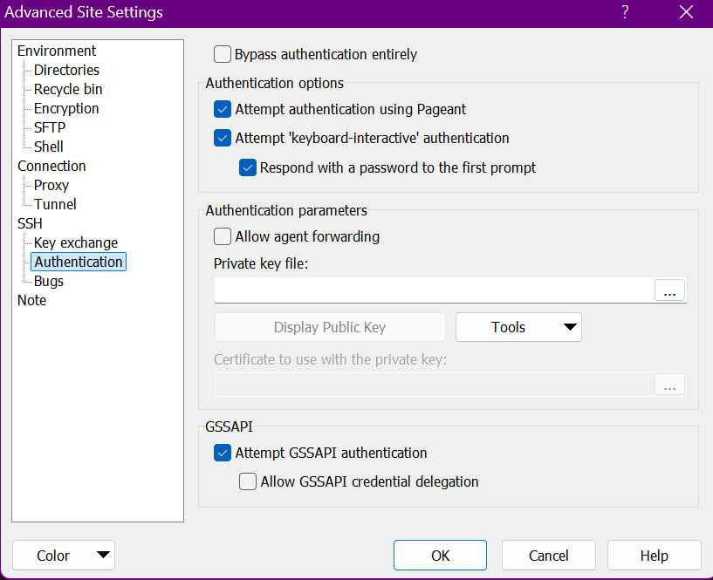

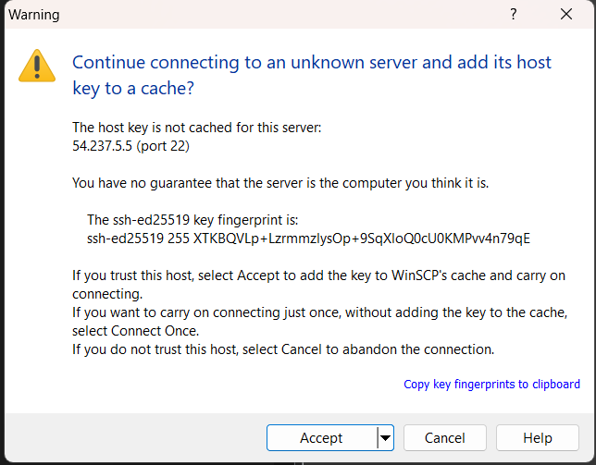  
  
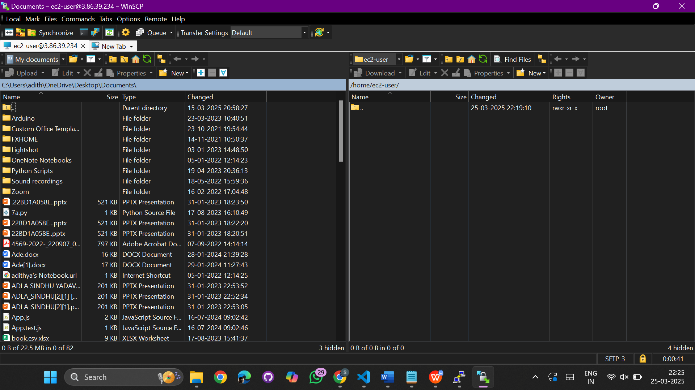  
  
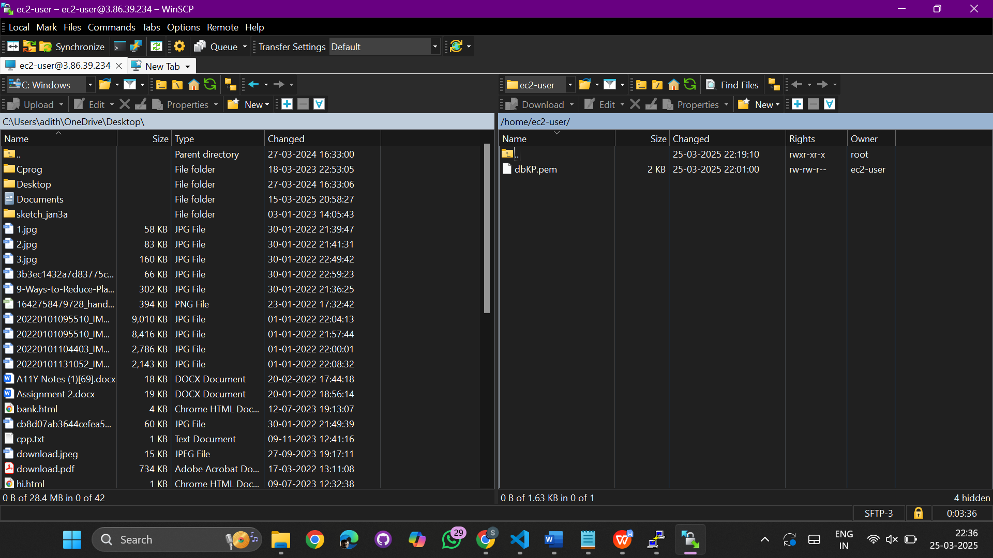  
  
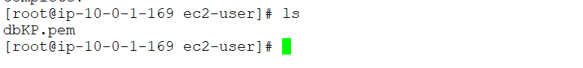  
  
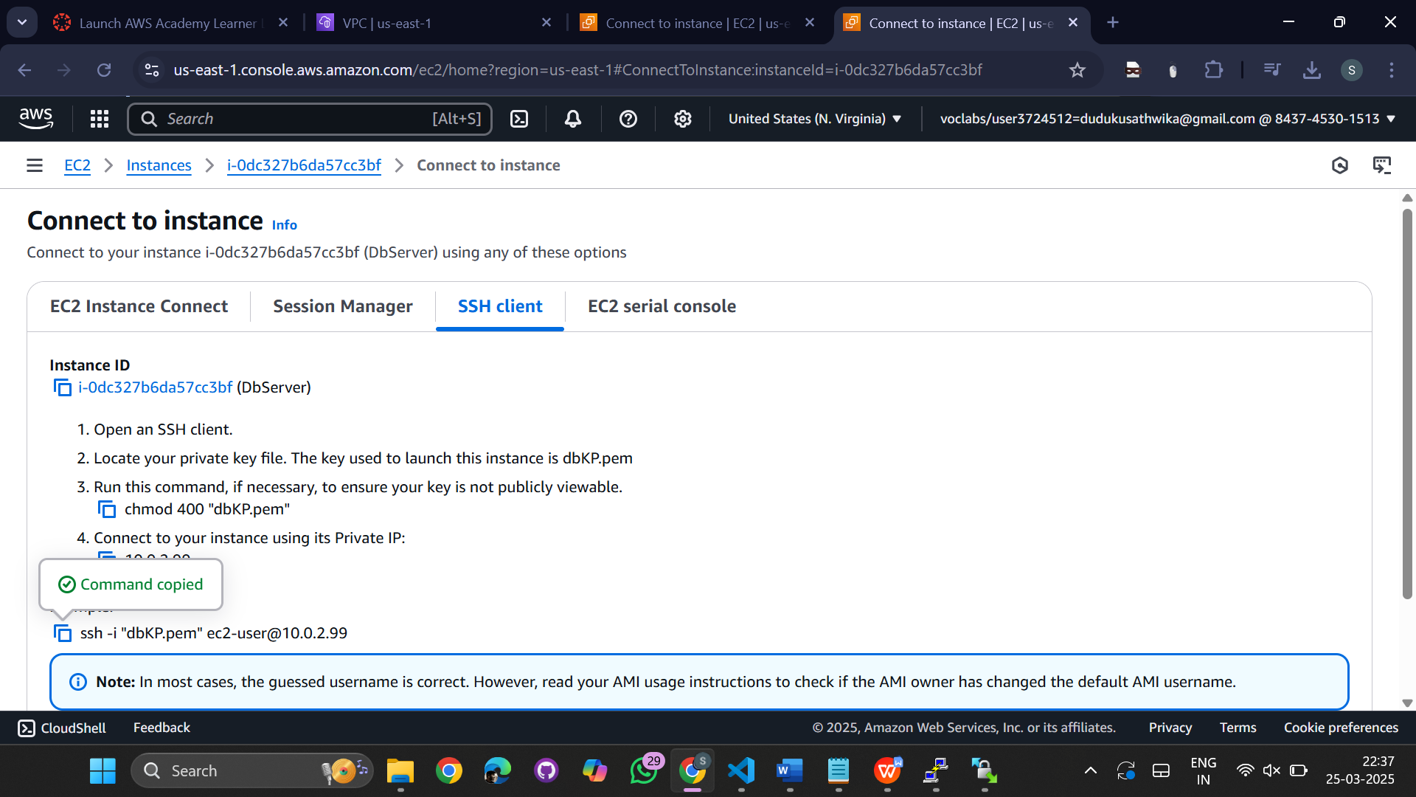  
  
  
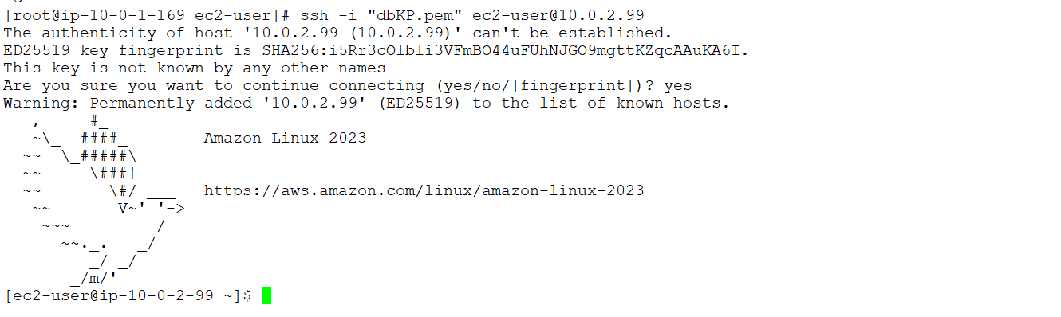  
  
  
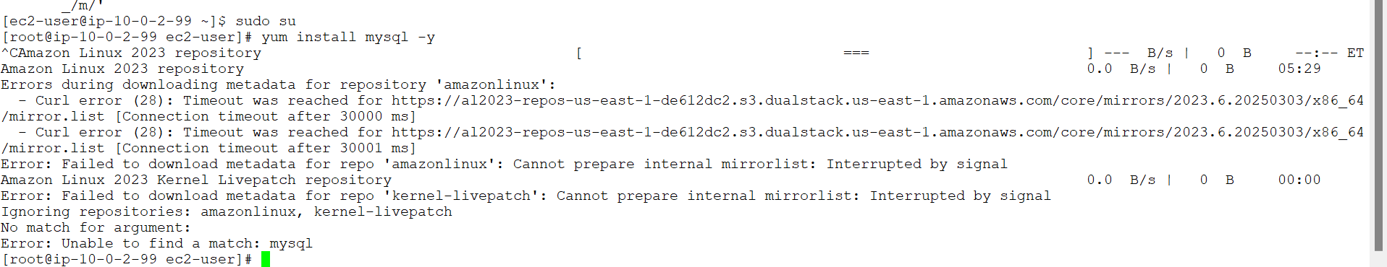  
  
  
**Here we are unable to get internet in the private instance to get the internet in the private instance we have to create a nat gateway which is network address translation**

**Go to NAT Gateway**

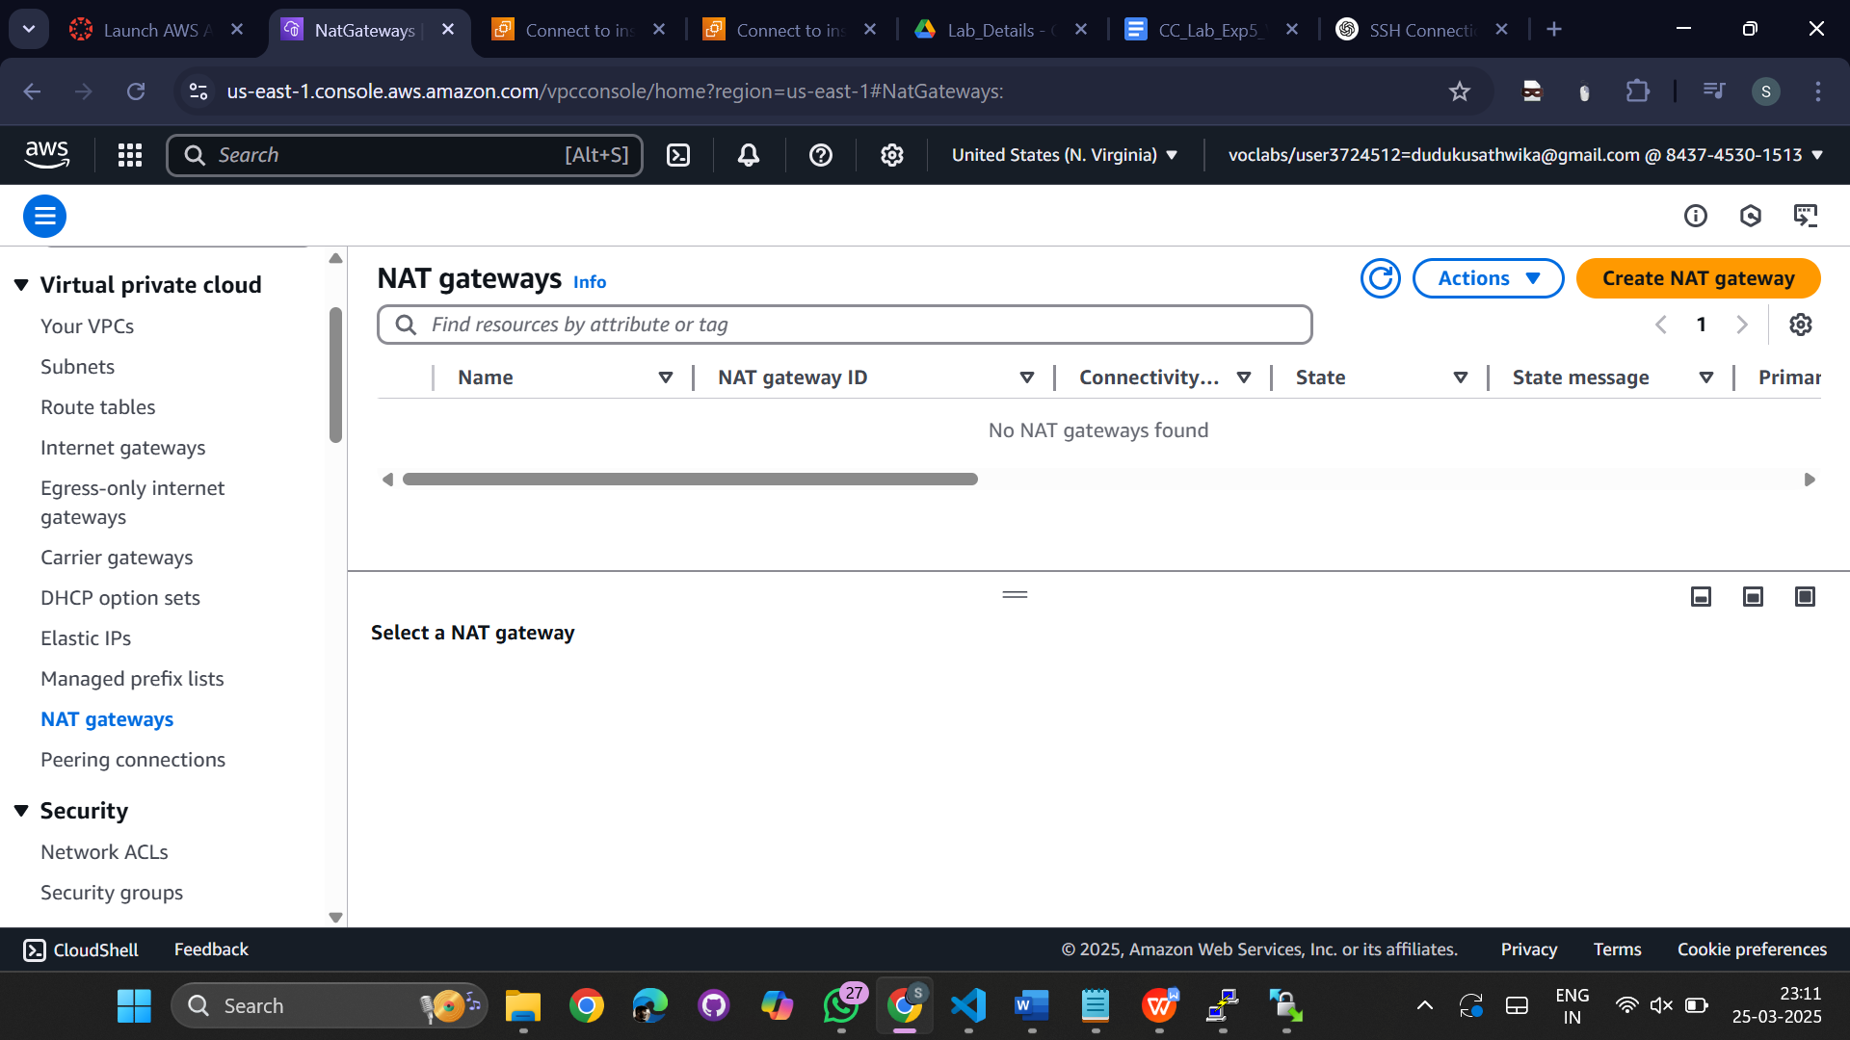  
  
**Click on create NAT gateway**

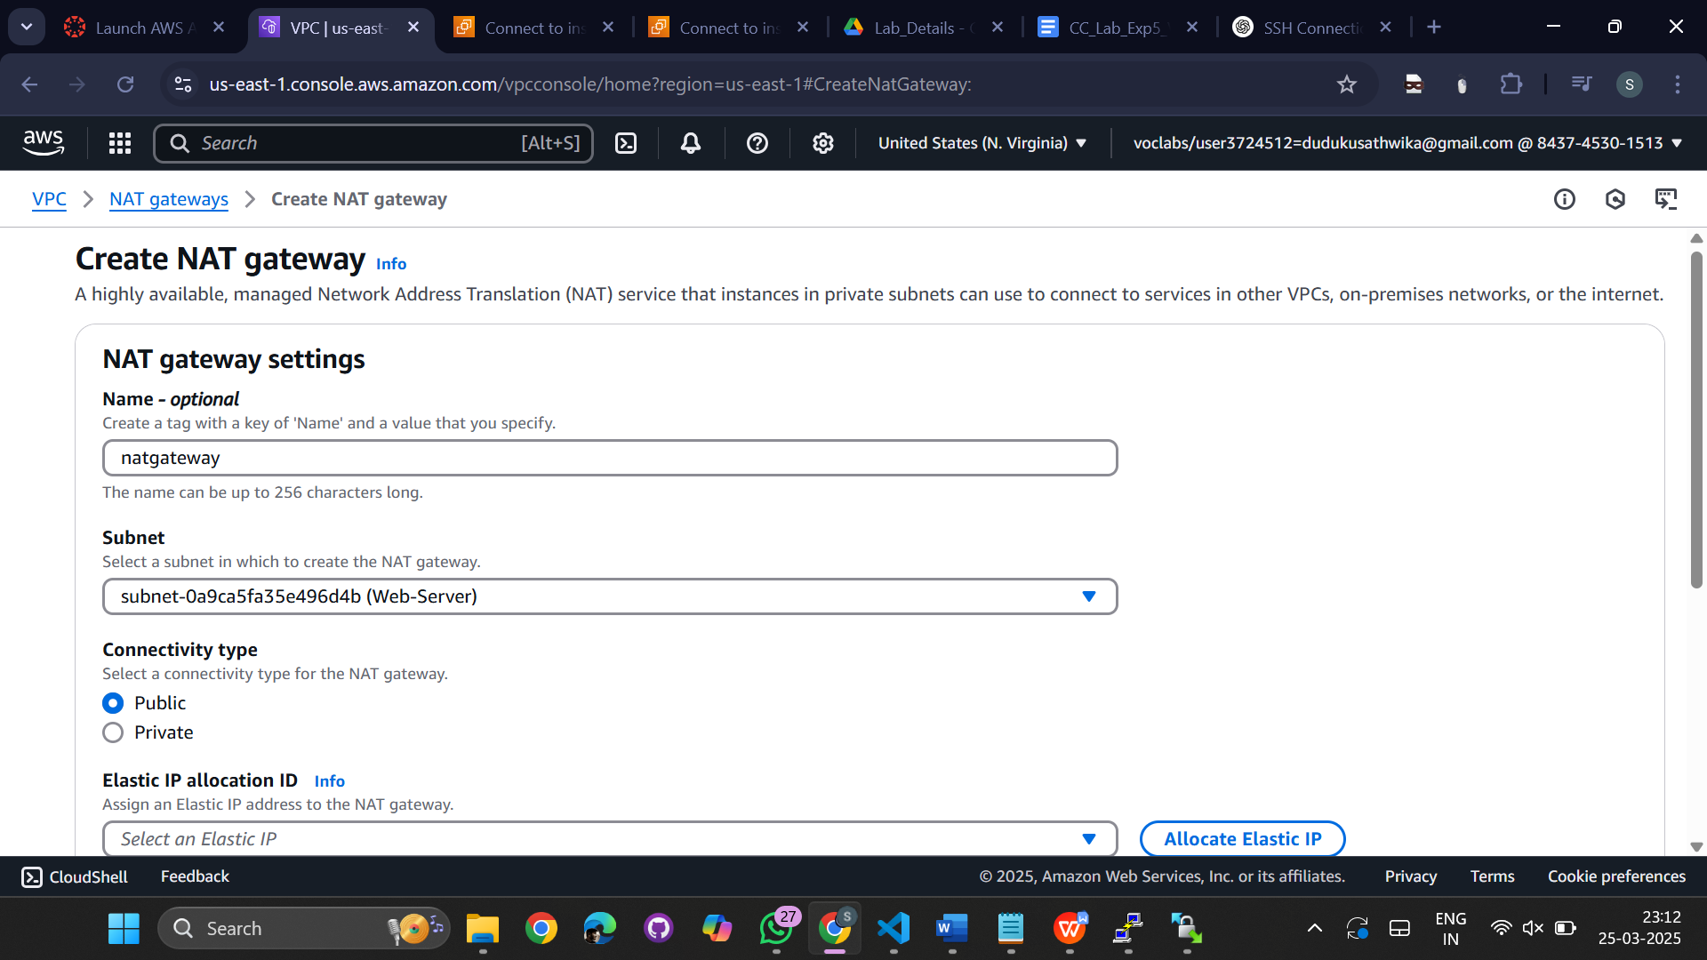  
  
**Give a name and subnet which is public and click on c**

**Allocate Elastic IP allocation**

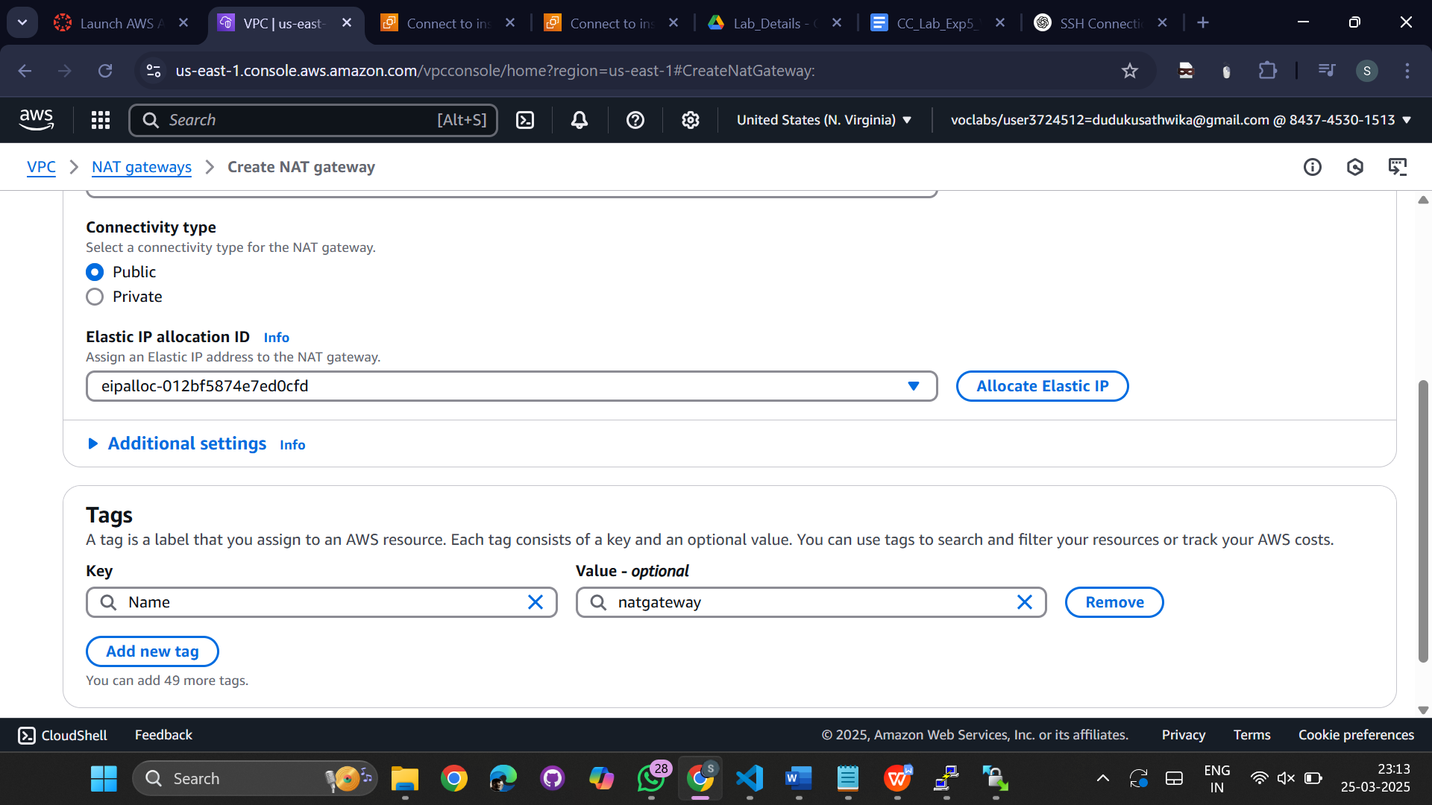  
  
**Successfully a NAT gateway is created**

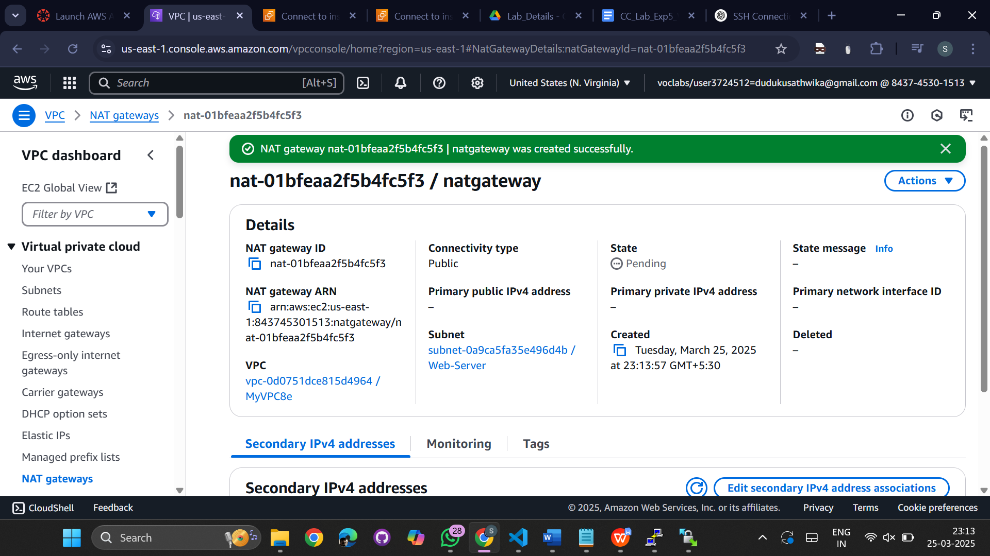  
  
**Create a route table for private subnet connection to nat gateway**

**Select the custom vpc we created**

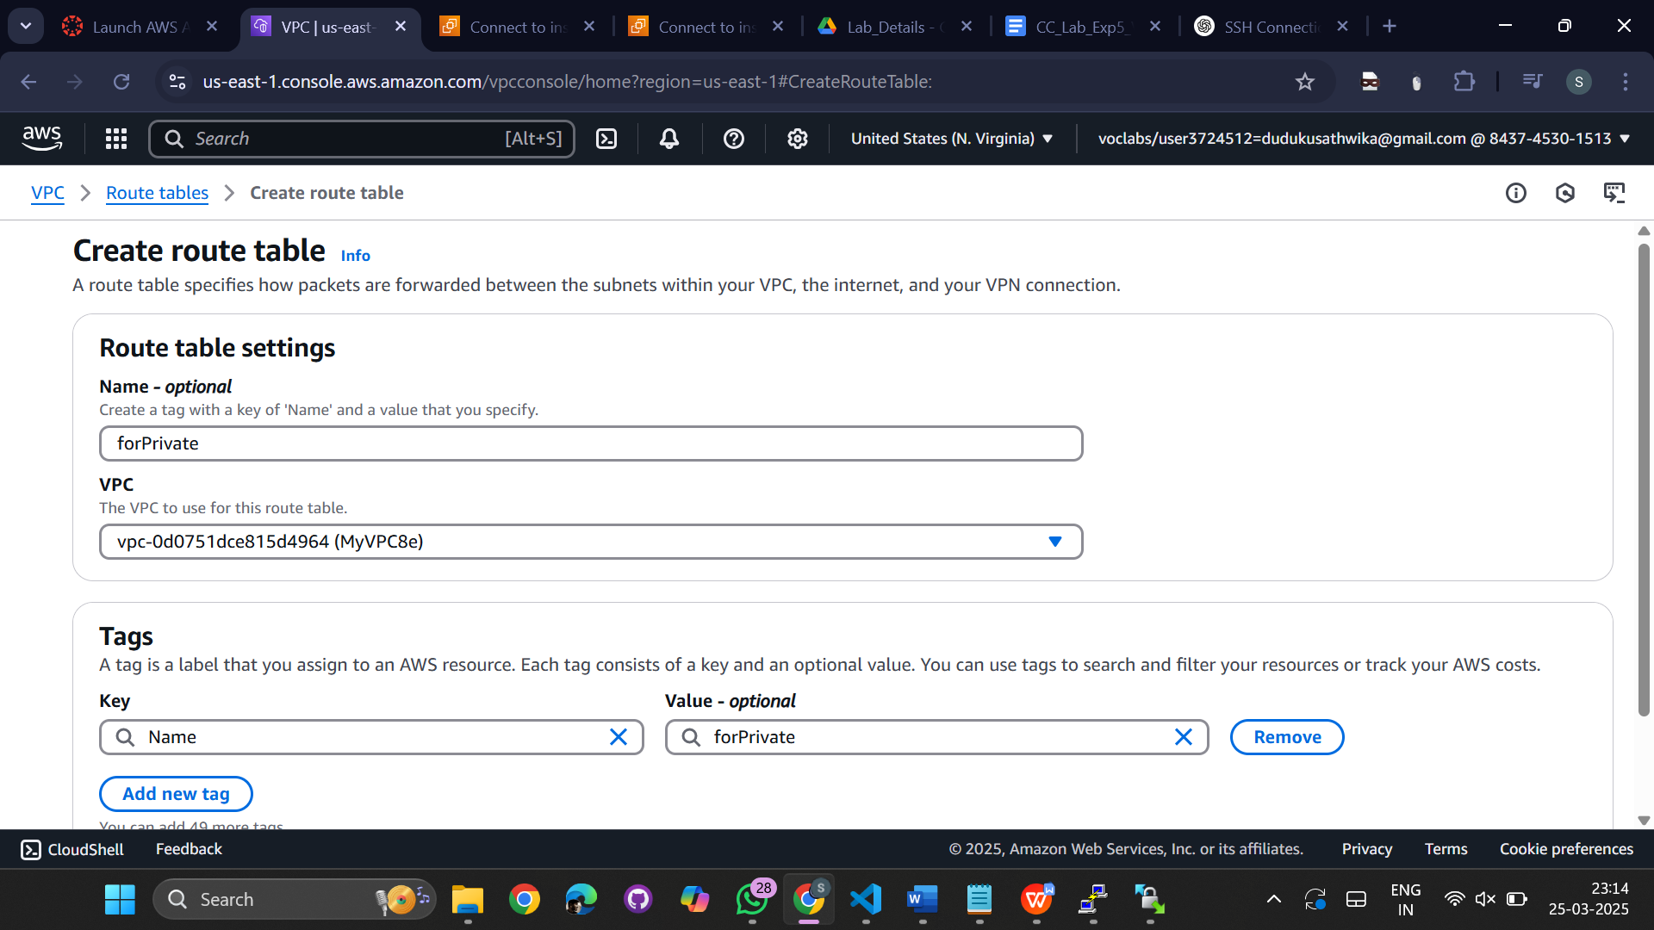  
  
**We have successfully created a route table for private subnet**

**Now select route table -> Edit routes -> Add natGateway**

**Click on save changes**

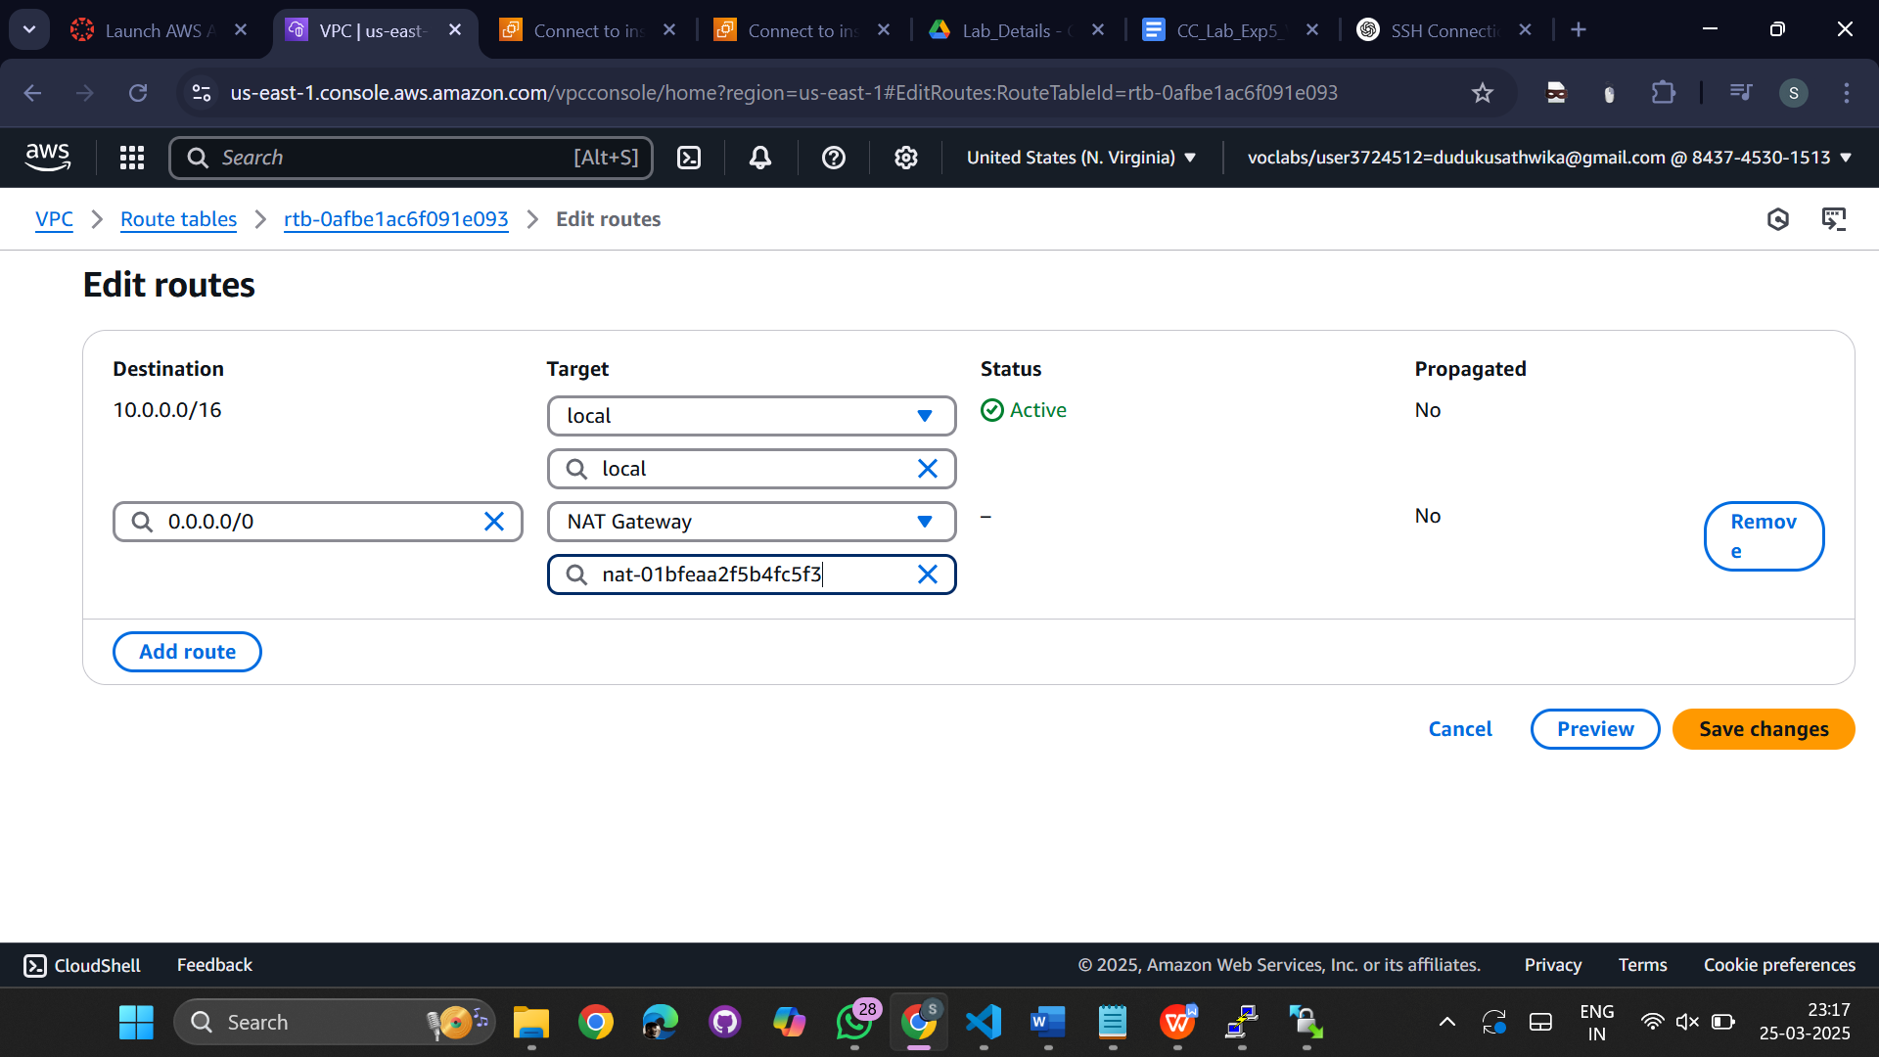  
  
**Now select forprivate->edit subnet Association   
Add private subnet to the associations**

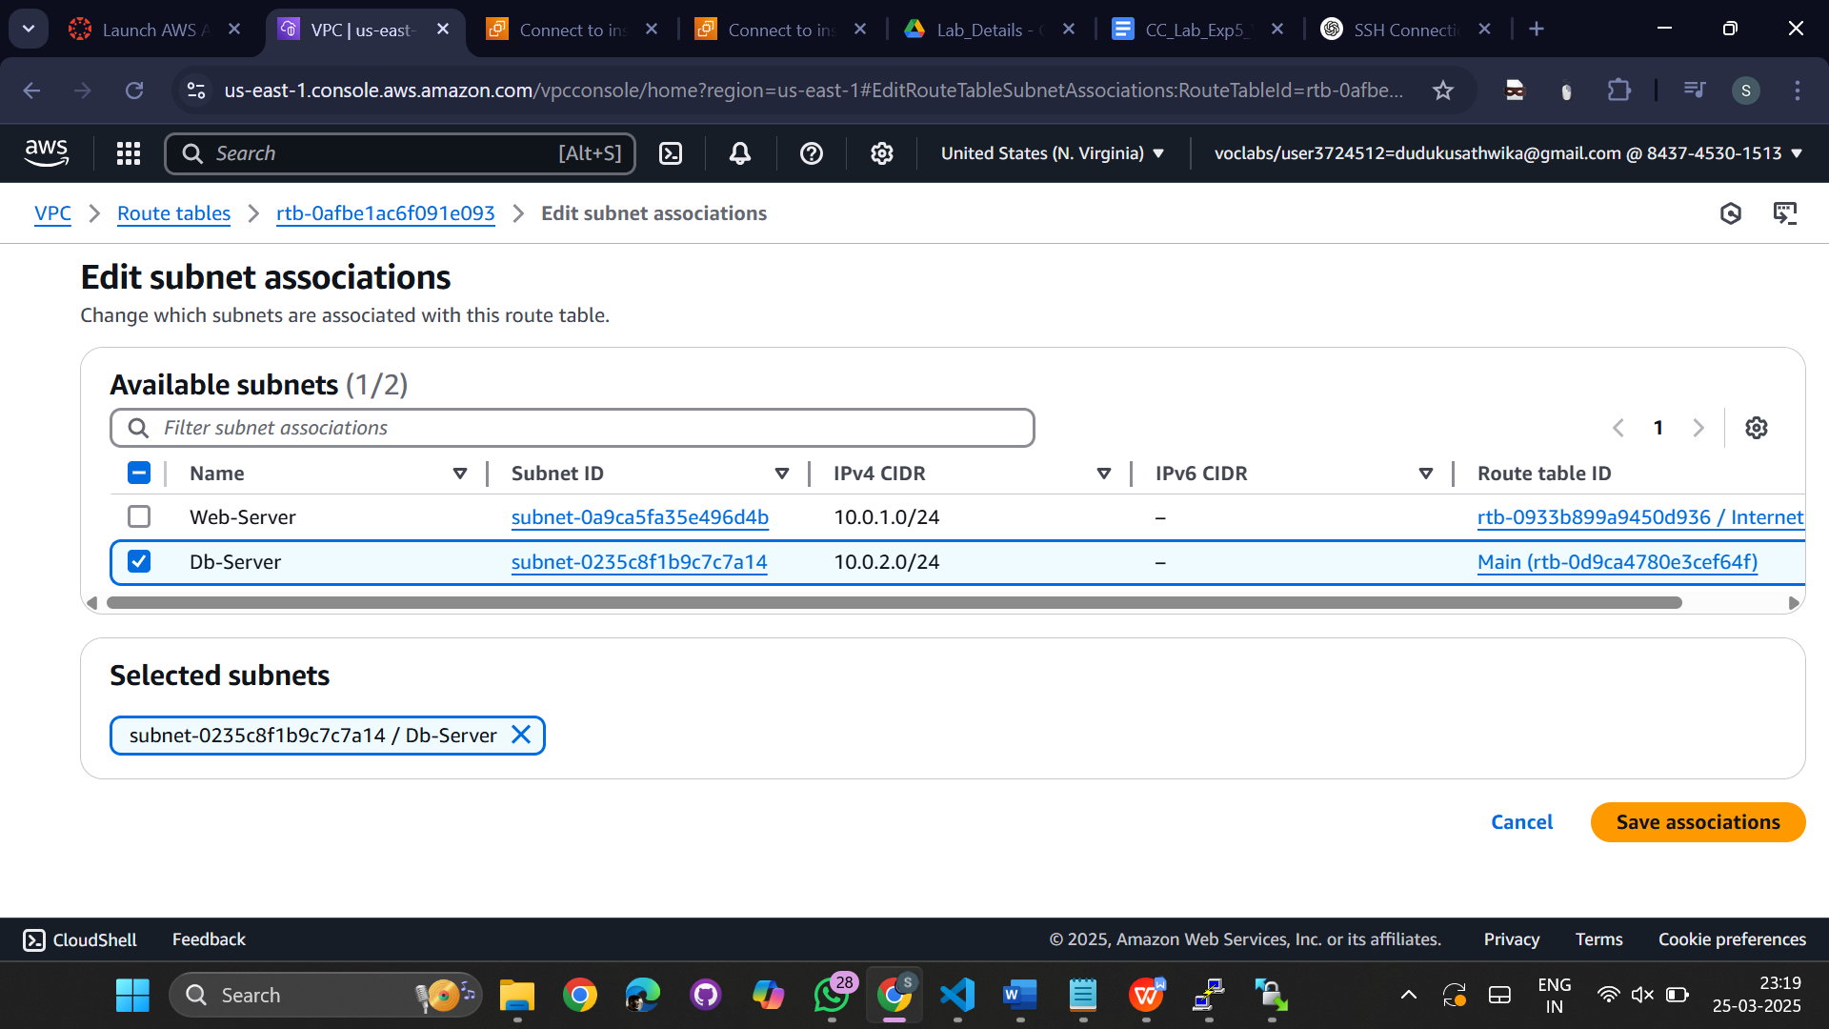

**For internetRt the subnet associations should be public subnet**

**Here we can see that internet is getting in the private instance i.e DBserver instance**

